Chapter 1: Introduction to Django

Activity 1.01: Creating a Site Welcome Screen

The following steps will help you complete this activity:

1. The index view in views.py should now just be one line, which returns the rendered template:

def index(request):

    return render(request, "base.html")

1. Update base.html; the <title> tag should contain Welcome to Bookr:

<head>

    <meta charset="UTF-8">

    <title>Welcome to Bookr</title>

</head>

The <body> tag should contain an h1 tag with the same message:

<body>

<h1>Welcome to Bookr</h1>

</body>

The index page of your site should now look like Figure 1.54:

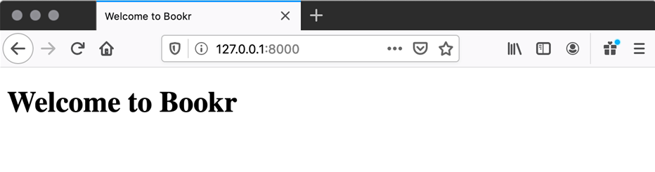

Figure 1.54: Bookr welcome screen

You have created a welcome splash page for Bookr, to which we will be able to add links to other parts of the site, as we build them.

Activity 1.02: Book Search Scaffold

The following steps will help you complete this activity:

1. Create a new file HTML file in the templates directory named search-results.html. Use a variable (search_text) in the <title> tag:

<head>

    <meta charset="UTF-8">

    <title>Search Results: {{ search_text }}</title>

</head>

Use the same search_text variable in an <h1> tag inside the body:

<body>

<h1>Search Results for <em>{{ search_text }}</em></h1>

</body>

1. Create a new function in views.py called book_search. It should create a variable called search_text that is set from the search parameter in the URL:

def book_search(request):

    search_text = request.GET.get("search", "")

If no search parameter is provided, it will default to an empty string.

1. Then, render the search-results.html template with search_text in the context:

    return render(request, "search-results.html", \

                  {"search_text": search_text})

1. Add a URL mapping to urlpatterns in urls.py:

    path('book-search', reviews.views.book_search)

Visit http://127.0.0.1:8000/book-search?search=test to see the output for the search string test (Figure 1.55):

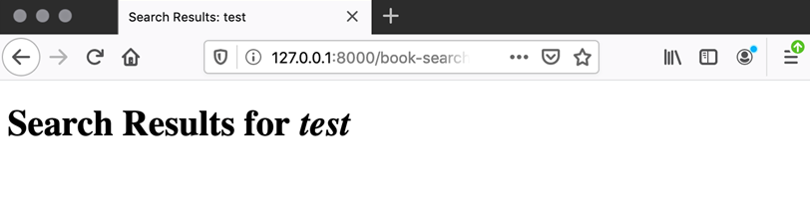

Figure 1.55: Searching for the string test

Try changing test to other values to see it in action, for example, Web Development with Django. Also, try the text </html> to see how HTML entities are automatically escaped when rendered in a template. Refer to Figure 1.52 and Figure 1.53 to see how your page should look for the latter two examples.

Chapter 2: Models and Migrations

Activity 2.01: Create Models for a Project Management Application

First, create a separate project in PyCharm. To configure Django correctly, for this activity, go through all the instructions in the Preface. Then, follow these instructions to complete the activity:

1. Create the juggler project by running the following command in the shell:

django-admin startproject juggler

1. Create an app called projectm:

django-admin startapp projectm

1. Add the app projects in juggler/settings.py under INSTALLED_APPS:

INSTALLED_APPS = ['django.contrib.admin',\

                  'django.contrib.auth',\

                  'django.contrib.contenttypes',\

                  'django.contrib.sessions',\

                  'django.contrib.messages',\

                  'django.contrib.staticfiles',\

                  'projectm']

1. Enter the following code to create the models:

models.py

01  from django.db import models

02

03

04  class Project(models.Model):

05    name = models.CharField(max_length=50,\

                              help_text="Project Name")

06    creation_time = models.DateTimeField\

                      (auto_now_add=True,\

                       help_text="Project creation time.")

The full code can be found at http://packt.live/3iCh8dj

1. Create the migration scripts and migrate the models by executing the following commands separately:

python manage.py makemigrations

python manage.py migrate

1. Open the Django shell using the following command:

python manage.py shell

1. In the shell, add the following code to import the model classes:

>>> from projectm.models import Project, Task

1. Create a project while assigning the object to a variable:

>>> project = Project.objects.create(name='Paint the house')

1. Create tasks for the project:

>>> Task.objects.create(title='Paint kitchen', description='Paint the kitchen', project=project, time_estimate=4)

>>> Task.objects.create(title='Paint living room', description='Paint the living room using beige color', project=project, time_estimate=6)

>>> Task.objects.create(title='Paint other rooms', description='Paint other rooms white', project=project, time_estimate=10)

1. List all the tasks associated with the project:

>>> project.task_set.all()

<QuerySet [<Task: Buy paint and tools>, <Task: Paint kitchen>, <Task: Paint living room>, <Task: Paint other rooms>]>

1. Using a different query method, list all the tasks associated with the project:

>>> Task.objects.filter(project__name='Paint the house')

<QuerySet [<Task: Buy paint and tools>, <Task: Paint kitchen>, <Task: Paint living room>, <Task: Paint other rooms>]>

In this activity, given an application requirement, we created a project model, populated the database, and performed database queries.

Chapter 3: URL Mapping, Views and Templates

Activity 3.01: Implement the Book Details View

The following steps will help you complete this activity:

1. Create a file called bookr/reviews/templates/reviews/book_detail.html and add the following HTML code:

reviews/templates/reviews/book_detail.html

1  {% extends 'base.html' %}

2

3  {% block content %}

4        <br>

5        <h3>Book Details</h3>

6        <hr>

7        <span class="text-info">Title: </span> <span>{{ book.  
 title }}</span>

8        <br>

9        <span class="text-info">Publisher: </span><span>{{   
 book.publisher }}</span>

You can view the complete code at http://packt.live/38XSRei.

Like the books_list.html template, this template also inherits from the base.html file by using the following code:

{% extends 'base.html' %}

{% block content %}

{% endblock %}

Because it inherited from base.html, you will be able to see the navigation bar on the book details page as well. The remaining part of the template uses the context to display the details of the book.

1. Open bookr/reviews/views.py and append the view method as follows by retaining all the other code in the file as it is:

def book_detail(request, pk):

    book = get_object_or_404(Book, pk=pk)

    reviews = book.review_set.all()

    if reviews:

        book_rating = average_rating([review.rating for \

                                      review in reviews])

        context = {"book": book,\

                   "book_rating": book_rating,\

                   "reviews": reviews}

    else:

        context = {"book": book,\

                   "book_rating": None,\

                   "reviews": None}

    return render(request, "reviews/book_detail.html", \

                  context)

You will also need to add the following import statement at the top of the file:

from django.shortcuts import render, get_object_or_404

The book_detail function is the book details view. Here, request is the HTTP request object that will be passed to any view function upon invocation. The next parameter, pk, is the primary key or the ID of the book. This will be part of the URL path as invoked when we open the book's detail page. We have already added this code in bookr/reviews/templates/reviews/books_list.html:

<a class="btn btn-primary btn-sm active" role="button"   
 aria-pressed="true" href="/book/{{ item.book.id }}/">Reviews</a>

The preceding code snippet represents a button called Reviews on the books list page. Upon clicking this button, /book/<id> will be invoked. Note that {{ item.book.id }} refers to the ID or the primary key of a book. The Reviews button should look like this:

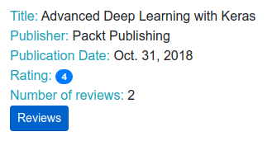

Figure 3.9: Reviews button below the details

1. Open bookr/reviews/urls.py and add a new path to the existing URL patterns as follows:

urlpatterns = [path('books/', views.book_list,\

                     name='book_list'),\

               path('books/<int:pk>/', views.book_detail,\

                    name='book_detail')]

Here, <int:pk> represents an integer URL pattern. The newly added URL path is to identify and map the /book/<id>/ URL of the book. Once it is matched, the book_detail view will be invoked.

1. Save all the modified files and once the Django service restarts, open http://0.0.0.0:8000/ or http://127.0.0.1:8000/ in the browser to see the book's details view with all the review comments:

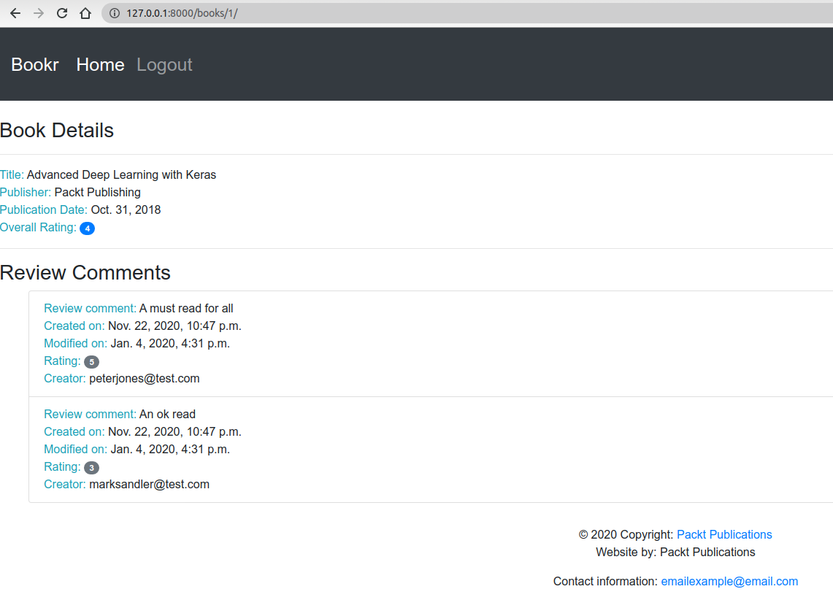

Figure 3.10: Page displaying the book details

In this activity, we implemented the book details view, template, and URL mapping to display all the details of the book and its review comments.

Chapter 4: Introduction to Django Admin

Activity 4.01: Creating a User Account

A user can be created with the following steps:

1. Visit the URL <http://127.0.0.1:8000/admin/>. Log in to the Admin app using the superuser account that you have already created from Exercise 4.01.

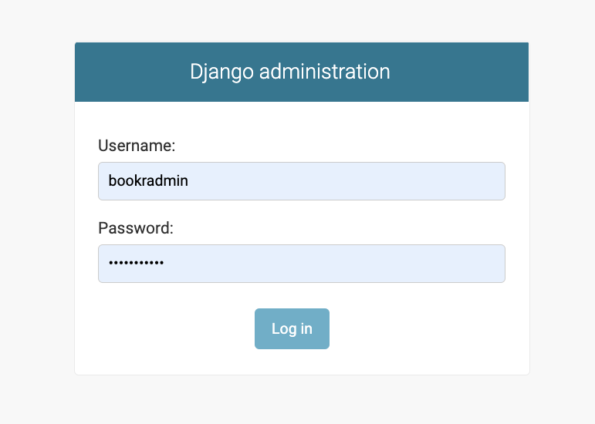  
Figure 4.63: The Django administration login form

1. Click on the **+ Add** link next to **User**.

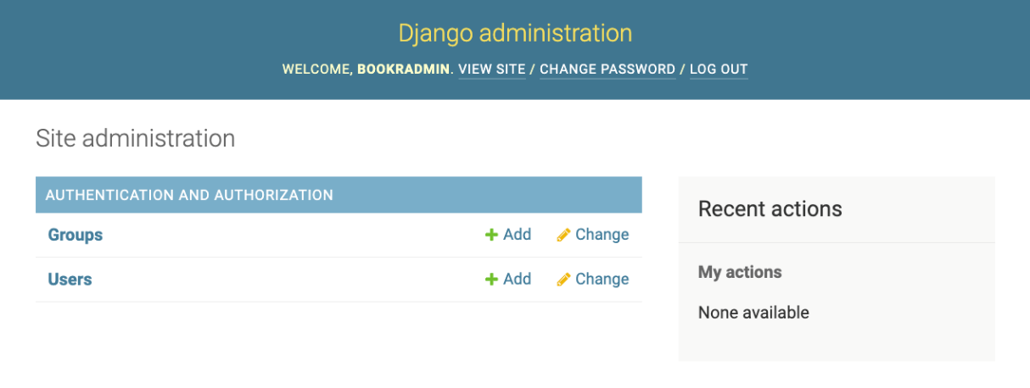

Figure 4.64: The Django administration window

1. Enter a username and password. Then click **Save and continue editing**.

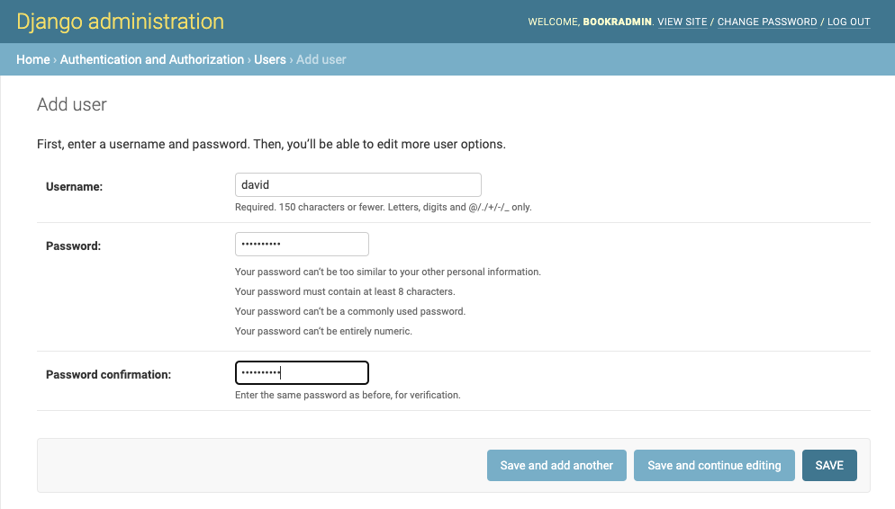  
Figure 4.65: The Add user page

1. The username and a hashing information for the password are prefilled. You can now enter **First name, Last name** and **Email Adress** under **Personal info**.

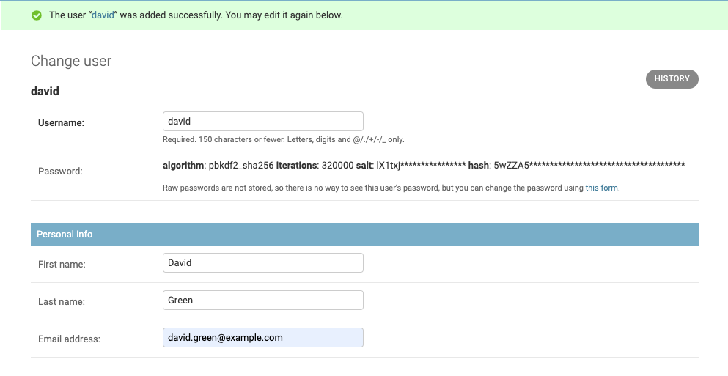  
Figure 4.66: The Change user page presented after clicking Save and continue editing

1. Under **Permissions** we were required to keep **Active** ticked and also tick **Staff status**.  
   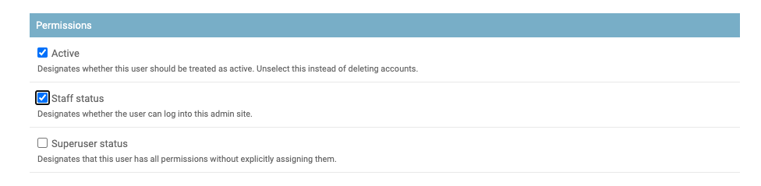

Figure 4.67 User permissions options

1. Scroll to the bottom of the page and click **Save**.

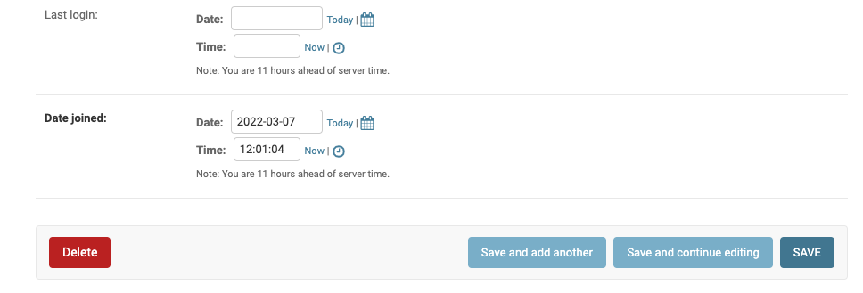  
Figure 4.68 The Delete and Save buttons at the bottom of the User add form

When you complete the steps in this activity, you will be returned to the User change list page, where there is a success status message and a new listing for the created user.

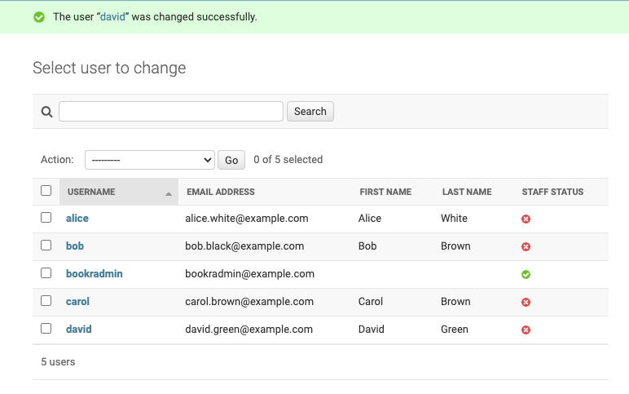  
Figure 4.69 The Delete and Save buttons at the bottom of the User add form

Activity 4.02: Customizing the SiteAdmin

Let's complete the activity with the following steps:

1. Create the Django project app, run the migrations, create the superuser, and run the app:

django-admin startproject comment8or

cd comment8or/

python manage.py startapp messageboard

python manage.py migrate

Operations to perform:

  Apply all migrations: admin, auth, contenttypes, sessions

Running migrations:

  Applying contenttypes.0001_initial... OK

  Applying auth.0001_initial... OK

  Applying admin.0001_initial... OK

  Applying admin.0002_logentry_remove_auto_add... OK

  Applying admin.0003_logentry_add_action_flag_choices... OK

  Applying contenttypes.0002_remove_content_type_name... OK

  Applying auth.0002_alter_permission_name_max_length... OK

  Applying auth.0003_alter_user_email_max_length... OK

  Applying auth.0004_alter_user_username_opts... OK

  Applying auth.0005_alter_user_last_login_null... OK

  Applying auth.0006_require_contenttypes_0002... OK

  Applying auth.0007_alter_validators_add_error_messages... OK

  Applying auth.0008_alter_user_username_max_length... OK

  Applying auth.0009_alter_user_last_name_max_length... OK

  Applying auth.0010_alter_group_name_max_length... OK

  Applying auth.0011_update_proxy_permissions... OK

  Applying sessions.0001_initial... OK

python manage.py createsuperuser

Username (leave blank to use '<your system username>'): c8admin

Email address: c8admin@example.com

Password:

Password (again):

Superuser created successfully.

python manage.py runserver

Copy the template from the Django source, django/contrib/admin/templates/registration/logged_out.html, to an appropriate path in the project directory, comment8or/templates/comment8or/logged_out.html.

1. Replace the text Thanks for spending some quality time with the Web site today., with Bye from c8admin.:

{% extends "admin/base_site.html" %}

{% load i18n %}

{% block breadcrumbs %}<div class="breadcrumbs">  
 <a href="{% url 'admin:index' %}">  
 {% trans 'Home' %}</a></div>{% endblock %}

{% block content %}

<p>{% trans "Bye from c8admin." %}</p>

<p><a href="{% url 'admin:index' %}">{% trans 'Log in again' %}  
 </a></p>

{% endblock %}

1. Add admin.py to the project directory with the following code:

from django.contrib import admin

class Comment8orAdminSite(admin.AdminSite):

    index_title = 'c8admin'

    title_header = 'c8 site admin'

    site_header = 'c8admin'

    logout_template = 'comment8or/logged_out.html'

1. Create a file called messageboard/adminconfig.py and add a custom AdminConfig subclass as follows:

from django.contrib.admin.apps import AdminConfig

class MessageboardAdminConfig(AdminConfig):

    default_site = 'admin.Comment8orAdminSite'

1. In the INSTALLED_APPS variable of comment8or/settings.py, replace the admin app with the custom AdminConfig subclass, messageboard.adminconfig.MessageboardAdminConfig, and add the messageboard app:

INSTALLED_APPS = [**'messageboard.adminconfig.MessageboardAdminConfig'**,

                  'django.contrib.auth',

                  'django.contrib.contenttypes',

                  'django.contrib.sessions',

                  'django.contrib.messages',

                  'django.contrib.staticfiles',

                  'messageboard',]

1. Configure the TEMPLATES setting so that the project's template is discoverable in comment8or/settings.py:

TEMPLATES = [{'BACKEND':

              'django.template.backends.django.DjangoTemplates',

              'DIRS':

              [os.path.join(BASE_DIR, 'comment8or/templates')],

              …}]

By completing this activity, you have created a new project and successfully customized the admin app by sub-classing AdminSite. The customized admin app in your Comment8r project should look something like this:

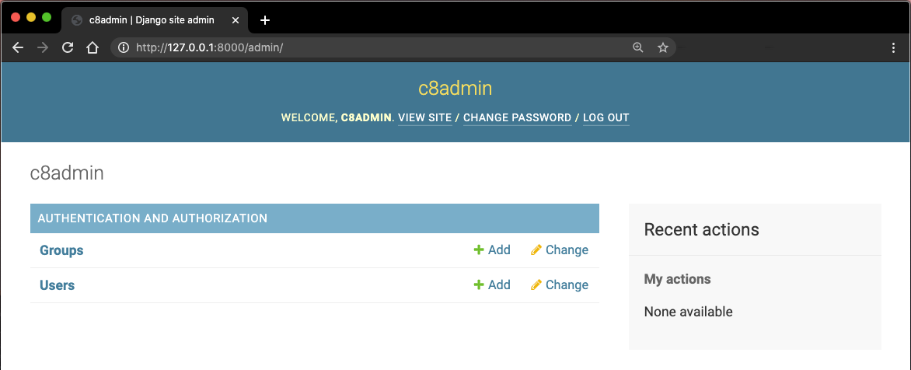

Figure 4.70: App index page after customization

Activity 4.03: Customizing the Model Admins

The following steps will help you complete this activity:

1. The default list display for the Contributors change list uses the Model.__str__ method's representation of class name followed by id, such as Contributor (12), Contributor(13), and so on, as follows:

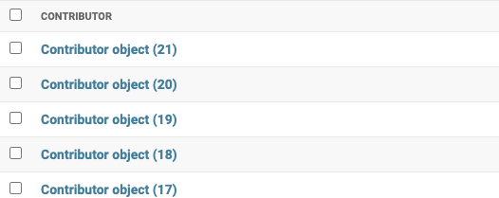

Figure 4.71: Default display for the Contributors change list

In Chapter 2, Models and Migrations, a __str__ method is added to the Contributor model so that each contributor is represented by first_names:

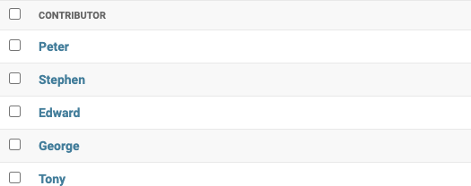

Figure 4.72: Contributors represented by first names

These steps are to create a more intuitive string representation of the contributor, such as Salinger, JD instead of Contributor (12).

1. Edit reviews/models.py and add an appropriate initialled_name method to Contributor.

This code gets a string of initials of the contributor's First Names and then returns a string with the Last Names followed by the initials:

    def initialled_name(self):

""" self.first_names='Jerome David',

self.last_names='Salinger'

=> 'Salinger, JD' """

initials = ''.join([name[0] for name

in self.first_names.split(' ')])

return "{}, {}".format(self.last_names, initials)

1. Replace the __str__ method for Contributor with one that calls initialled_name():

def __str__(self):

return self.initialled_name()

After these steps, the Contributor class in reviews/models.py will look like this:

class Contributor(models.Model):

"""A contributor to a Book, e.g. author, editor, co-author."""

first_names = models.CharField(max_length=50,

help_text="The contributor's first name or names.")

last_names = models.CharField(max_length=50,

help_text="The contributor's last name or names.")

email = models.EmailField(

help_text="The contact email for the contributor.")

def initialled_name(self):

""" self.first_names='Jerome David',

self.last_names='Salinger'

=> 'Salinger, JD' """

initials = ''.join([name[0] for name

in self.first_names.split(' ')])

return "{}, {}".format(self.last_names, initials)

    def __str__(self):

        return self.initialled_name()

The Contributors change list will appear as follows:

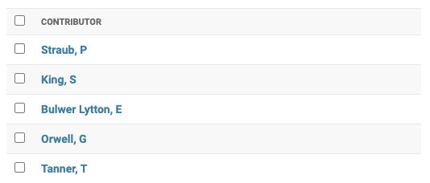

Figure 4.73: Contributors change list with the last name and initial of the first name

1. Add a ContributorAdmin class that inherits from admin.ModelAdmin:

class ContributorAdmin(admin.ModelAdmin):

1. Modify it so that on the Contributors change list, records are displayed with two sortable columns – Last Names and First Names:

    list_display = ('last_names', 'first_names')

1. Add a search bar that searches on Last Names and First Names. Modify it so that it only matches the start of Last Names:

    search_fields = ('last_names__startswith', 'first_names')

1. Add a filter on Last Names:

    list_filter = ('last_names',)

1. Modify the register statement for the Contributor class to include the ContributorAdmin argument:

admin.site.register(Contributor, ContributorAdmin)

The changes to reviews/admin.py should look like this:

class ContributorAdmin(admin.ModelAdmin):

    list_display = ('last_names', 'first_names')

    list_filter = ('last_names',)

    search_fields = ('last_names__startswith', 'first_names')

admin.site.register(Contributor, ContributorAdmin)

With the two sortable columns, the filter, and the search bar, the list will look like this:

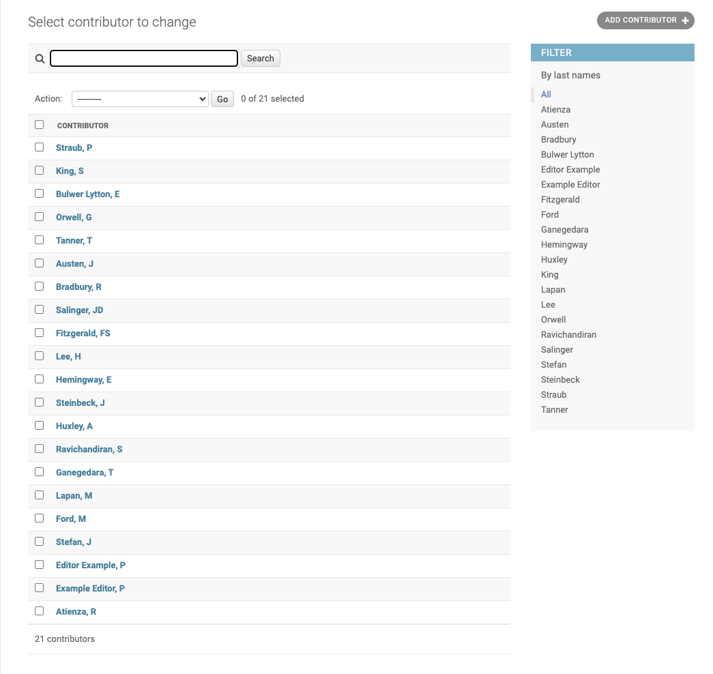

Figure 4.74: The completed Contributors change list

Chapter 5: Serving Static Files

Activity 5.01 Solution: Adding a reviews Logo

Perform the following steps to complete this activity:

1. Open base.html in the main templates directory. Find the <style> tags in the <head>, and add this rule at the end (after the .navbar-brand rule):

.navbar-brand > img {  
 height: 60px;  
}

After adding this rule to your <style> element, it should look like Figure 5.25.

Figure 5.22: new rule added into <style> element

1. Locate the following line:

<a class="navbar-brand" href="/">Book Review</a>

It will be just inside the start of the <body>. Change it to add {% block brand %} and {% endblock %} wrappers around the text:

<a class="navbar-brand" href="/">{% block brand %}Book Review{% endblock %}</a>

You can save and close base.html.

1. Create a directory named static, inside the reviews app directory. Inside this static directory, create a directory named reviews. Put the logo.png from https://raw.githubusercontent.com/PacktPublishing/Web-Development-with-Django-Second-Edition/main/Chapter05/Activity5.01/bookr/reviews/static/reviews/logo.png inside this directory. Your final directory structure should look like this:

Figure 5.23: Layout of reviews static directory with logo.png

1. Create a templates directory inside the Bookr project directory. Move the reviews/templates/reviews/base.html file into this directory.

Your directory structure should look like this:

Figure 5.24: Layout of project templates directory

1. Open settings.py and locate the TEMPLATES = … setting. Add BASE_DIR / "templates" into the DIRS setting, so the TEMPLATES setting looks like this:

TEMPLATES = [  
 {  
 "BACKEND": "django.template.backends.django.DjangoTemplates",  
 "DIRS": [BASE_DIR / "templates"],  
 "APP_DIRS": True,  
 "OPTIONS": {  
 "context_processors": [  
 "django.template.context_processors.debug",  
 "django.template.context_processors.request",  
 "django.contrib.auth.context_processors.auth",  
 "django.contrib.messages.context_processors.messages",  
 ],  
 },  
 },  
]

Save and close settings.py.

1. Right-click on the reviews namespaced template directory and choose New | File (not New | HTML File, as we don’t require the HTML boilerplate that would generate). Name the file base.html.

The file will open. Add an extends template tag to the file, to extend from base.html:

{% extends 'base.html' %}

1. We will use the {% static %} template tag to generate the img URL, so we need to make sure the static library is loaded. Add this line after the extends line:

{% load static %}

Then override the {% block brand %} content, and use the {% static %} template tag to generate the URL to the reviews/logo.png file:

{% block brand %}<img src="{% static 'reviews/logo.png' %}">{% endblock %}

There should now be three lines in this new base.html file. You can save and close it. The completed file is available at https://raw.githubusercontent.com/PacktPublishing/Web-Development-with-Django-Second-Edition/main/Chapter05/Activity5.01/bookr/reviews/templates/reviews/base.html.

Start the Django Dev server, if it’s not already running. The pages you should check are the home page, which should look the same. Then the books list page and book detail page, these should have the Bookr Reviews logo displayed.

Activity 5.02: CSS Enhancements

Perform the following steps to complete this activity:

1. In PyCharm, right click on the bookr project directory and select New | Directory. Name it static. Right click on this directory and select New -> File. Name the file main.css. Your directory layout should look like Figure 5.26 after doing this.

Figure 5.26: main.css File added

1. Open the main base.html file, then find the style element in the head. Copy its contents (but not the <style> and </style>) tags themselves into the main.css file. Then at the end, add the CSS snippet given in the activity instructions. Your file should contain this content when finished:

.navbar {  
 min-height: 100px;  
 font-size: 25px;  
}  
  
.navbar-brand {  
 font-size: 25px;  
}  
  
.navbar-brand > img {  
 height: 60px;  
}  
  
body {  
 font-family: 'Source Sans Pro', sans-serif;  
 background-color: #e6efe8;  
 color: #393939;  
}  
  
h1, h2, h3, h4, h5, h6 {  
 font-family: 'Libre Baskerville', serif;  
}

You can save and close main.css. Then return to base.html and remove the entire style element.

The complete main.css can be found at https://github.com/PacktWorkshops/The-Django-Workshop/blob/master/Chapter05/Activity5.02/bookr/static/main.css

1. Load the static library on the second line of base.html, by adding this:

{% load static %}

Then you can use the {% static %} tag to generate the URL for the main.css, to be used in a link element:

<link rel="stylesheet" href="{% static 'main.css' %}">

Insert this into the head of the page, where the <style> was before you removed it.

1. Underneath the <link> you added in the previous step, add this to include the Google fonts CSS:

<link rel="stylesheet" href="https://fonts.googleapis.com/css?family=Libre+Baskerville|Source+Sans+Pro&display=swap">

You can now save and close base.html. The completed file can be found at https://github.com/<newurl>/blob/master/Chapter05/Activity5.02/bookr/templates/base.html

1. Open settings.py in the bookr package directory. Scroll to the bottom of the file and add this line:

STATICFILES_DIRS = [BASE_DIR / "static"]

This will set the STATICFILES_DIRS setting to a single-element list containing the path to the static directory in your project. This will allow Django to locate the main.css file. The completed settings.py can be found at https://github.com/PacktWorkshops/The-Django-Workshop/blob/master/Chapter05/Activity5.02/bookr/bookr/settings.py

1. Start the Django dev server – you may need to restart it to load the changes to settings.py. Then visit http://127.0.0.1:8000/ in your browser. You should see updated fonts and background colors on all the Bookr pages:

Figure 5.27: Book List with new font

Activity 5.03: Adding a Global Logo

Perform the following steps to complete this activity:

1. Download the logo.png file from https://raw.githubusercontent.com/PacktPublishing/Web-Development-with-Django-Second-Edition/main/Chapter05/Activity5.03/bookr/static/logo.png
2. Move the logo into the project static directory (not the reviews static directory).

Figure 5.30: Bookr project directory layout

Figure 5.29 shows the Project Pane in PyCharm illustrating the correct location for logo.png.

1. Open templates/base.html (not reviews/templates/reviews/base.html). Locate the {% block brand %} template tag (inside the tag <a class="navbar-brand">). It will have the content Book Review, like this:

{% block brand %}Book Review{% endblock %}

Change the content to be an <img> tag. The src attribute should use the static template tag to generate the URL of logo.png, like this:

{% block brand %}<img src="{% static 'logo.png' %}">{% endblock %}

You have already loaded the static template tag library (by adding the load template tag) in Activity 5.01.

Note that like main.css, logo.png is not namespaced, so we don’t need to include a directory name.

1. Start the Django Dev Server if it is not already running and then open http://127.0.0.1:8000/ in your browser. You should see the main Bookr page now has the Bookr logo, like the following figure.

Figure 5.30: Bookr Logo on main page

In contrast if you open a reviews page like http://127.0.0.1:8000/books/, you’ll see the Bookr Reviews logo as you had previously. Refer to Figure 5.31 for how it should look.

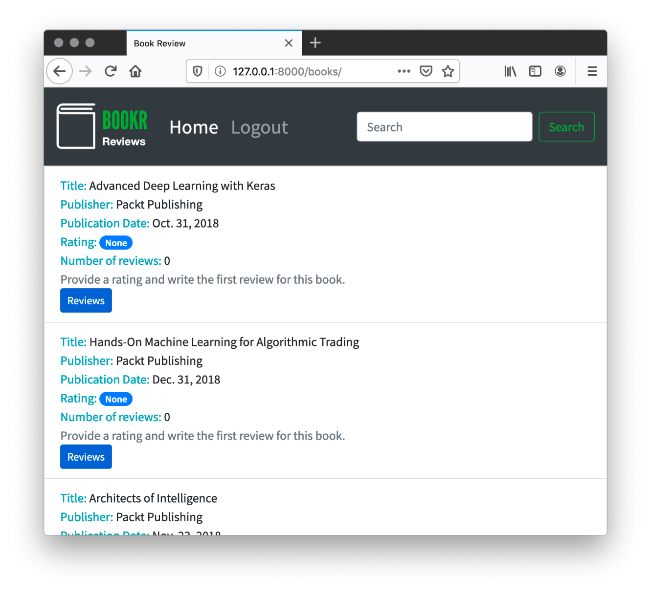

Figure 5.31: Bookr Reviews logo still shows on Reviews pages

In this activity, you added a global logo in the base template (base.html). The logo shows on all non-review pages, but the existing reviews logo still shows on the reviews pages.

You saw that with the use of namespacing, we can refer to each logo.png by the directory in which they reside (logo.png for the global logo and reviews/logo.png for the reviews specific logo). You used the static template tag to generate the URL to the logo file. This will allow for flexibility when deploying to production and gives us the option to easily change the static URL by updating the STATIC_URL setting.

Chapter 6: Forms

Activity 6.01: Book Searching

Perform the following steps to complete this activity:

1. Open forms.py in the reviews app. Create a new class called SearchForm that inherits from forms.Form. The class definition should look like this:

class SearchForm(forms.Form):

1. Add a CharField instance called search, which is instantiated with the required argument set to False and the min_length argument set to 3:

class SearchForm(forms.Form):

    search = forms.CharField(required=False, min_length=3)

This will ensure that the field does not need to be filled in, but if data is entered, it must be at least three characters long before the form is valid.

1. Add a ChoiceField instance named search_in. It should also be instantiated with the required argument set to False. The choices argument should be a tuple of tuples in the form (value, description):

(("title", "Title"), ("contributor", "Contributor"))

Note that this could be a list of lists, a tuple of tuples, or any combination of the two – this is also valid:

[("title", "Title"), ["contributor", "Contributor"]]

Ideally, though, you would be consistent in your choice of objects; that is, all tuples or all lists.

After completing steps 1 to 3, your completed SearchForm class should look like this:

class SearchForm(forms.Form):

    search = forms.CharField(required=False, min_length=3)

    search_in = forms.ChoiceField(required=False,

                                  choices=(("title", "Title"),

                                           ("contributor",\

                                            "Contributor")))

1. Open the reviews app's views.py file. First, make sure SearchForm is imported. You will already be importing ExampleForm, so just add SearchForm to the import line. Take the following line:

from .forms import ExampleForm

And change it to this:

from .forms import ExampleForm, SearchForm

Then, inside the book_search view, instantiate a SearchForm instance, passing in request.GET. Assign this to the form variable:

def book_search(request):

    search_text = request.GET.get("search", "")

    form = SearchForm(request.GET)

1. In the book_search view, you will need to add a placeholder books empty set variable, which will be used in the render context if the form is not valid. We will also use it to build the results in the next step:

def book_search(request):

    # Code from Step 4 truncated

    books = set()

Then we should only proceed with a search if the form is valid and some search text has been entered (remember, the form is valid even if search is empty).

1. We will then check whether the form's cleaned_in value is "title", and if so, filter the Book objects using the title__icontains argument, to perform a case-insensitive search. Putting this all together, the book_search view up to this point should look like this:

def book_search(request):

    # Code from Step 4/6 truncated

    if form.is_valid() and form.cleaned_data["search"]:

        search = form.cleaned_data["search"]

        search_in = form.cleaned_data.get("search_in") or "title"

        if search_in == "title":

            books = Book.objects.filter(title__icontains=search)

1. Since we are going to be searching Contributors, make sure to import Contributor at the start of the file. Find the following line:

from .models import Book

Change it to this:

from .models import Book, Contributor

If the search_in value of SearchForm is not title, then it must be "contributor" (since there are only two options). An else branch can be added to the last if statement added in the previous step, which searches by Contributor.

You might want to search by Contributor by passing both arguments to the same filter call, as here:

contributors = Contributor.objects.filter(

    first_names__icontains=search,

    last_names__icontains=search)

But in this case, Django will perform this as an AND search, so the search term would need to be present for the first_names and last_names values of the same author.

Instead, we will perform two queries and iterate them separately. Every contributor that matches has each of their Book instances added to the books set that was created in the previous step:

fname_contributors = \

    Contributor.objects.filter(first_names__icontains=search)

for contributor in fname_contributors:

    for book in contributor.book_set.all():

        books.add(book)

lname_contributors = \

    Contributor.objects.filter(last_names__icontains=search)

for contributor in lname_contributors:

    for book in contributor.book_set.all():

        books.add(book)

Since books is a set instance instead of a list instance, duplicate Book instances are avoided automatically.

Note that you could also convert the query results to lists by passing them to the list constructor function and then combining them with the + operator. Then, just iterate over the single combined list:

contributors = list(Contributor.objects.filter\

                    (first_names__icontains=search)) + \

               list(Contributor.objects.filter\

                    (last_names__icontains=search))

for contributor in contributors:

    for book in contributor.book_set.all():

        books.add(book)

This is still not ideal, as we make two separate database queries. Instead, you can combine queries with an OR operator using the | (pipe) character. This will make just one database query:

contributors = Contributor.objects.filter\

               (first_names__icontains=search) |\

               Contributor.objects.filter\

               (last_names__icontains=search)

Then, again, only one contributor iterating loop is required:

for contributor in contributors:

    for book in contributor.book_set.all():

        books.add(book)

The book_search view should look like this at this point:

def book_search(request):

    search_text = request.GET.get("search", "")

    form = SearchForm(request.GET)

    books = set()

    if form.is_valid() and form.cleaned_data["search"]:

        search = form.cleaned_data["search"]

        search_in = form.cleaned_data.get("search_in") or "title"

        if search_in == "title":

            books = Book.objects.filter(title__icontains=search)

        else:

            fname_contributors = \

                Contributor.objects.filter\

                (first_names__icontains=search)

                for contributor in fname_contributors:

                    for book in contributor.book_set.all():

                        books.add(book)

            lname_contributors = \

                Contributor.objects.filter\

                (last_names__icontains=search)

            for contributor in lname_contributors:

                for book in contributor.book_set.all():

                    books.add(book)

1. The context dictionary being passed to render should include the search_text variable, form variable, and books variable – this might be an empty set. For simplicity, the keys can match the values. The second argument to render should include the reviews directory in the template path. The render call should look like this:

return render(request, "reviews/search-results.html", \

              {"form": form, "search_text": search_text,\

               "books": books})

1. Open search-results.html inside the reviews templates directory. Delete all its contents (since we created it before template inheritance was covered, its previous content is now redundant). Add an extends template tag at the start of the file, to extend from base.html:

{% extends 'base.html' %}

Under the extends template tag, add a block template tag for the title block. Add an if template tag that checks whether form is valid and whether search_text is set – if so, render Search Results for "{{ search_text }}". Otherwise, just render the static text Book Search. Remember to close the block with an endblock template tag. In the context of the extends template tag, your file should now look like this:

{% extends 'base.html'%}

{% block title %}

    {% if form.is_valid and search_text %}

        Search Results for "{{ search_text }}"

    {% else %}

        Book Search

    {% endif %}

{% endblock %}

1. After the title's endblock template tag, add the opening content block template tag:

{% block content %}

Add the <h2> element with the static text Search for Books:

<h2>Search for Books</h2>

Then, add a <form> element and render the form inside using the as_p method:

<form>

    {{ form.as_p }}

Your <button> element should be similar to the submit buttons you added in Activity 6.01, Book Searching, with submit as type and btn btn-primary for class. Its text content should be Search:

<button type="submit" class="btn btn-primary">Search</button>

Finally, close the form with a </form> tag.

Note that we don't need a {% csrf_token %} in this form since we're submitting it using GET rather than POST. Also, we will close the block with an endblock template tag in step 12.

1. Under the </form> tag, add an if template tag that checks whether the form is valid and whether search_text has a value:

{% if form.is_valid and search_text %}

As in the view, we need to check both of these because the form is valid even if search_text is blank. Add the <h3> element underneath:

<h3>Search Results for <em>{{ search_text }}</em></h3>

We won't close the if template tag yet as we use the same logic to show or hide the results, so we will close it in the next step.

1. First under <h3>, add an opening <ul> tag, with a list-group class:

<ul class="list-group">

Then, add the for template tag to iterate over the books variable:

{% for book in books %}

Each book will be displayed in an <li> instance with a list-group-item class. Use a span instance with a text-info class like what was used in book_list.html. Generate the URL of the link using the url template tag. The link text should be the book title:

<li class="list-group-item">

    <span class="text-info">Title:  
 </span> <a href="{% url 'book_detail' book.pk %}">{{ book }}</a>

Use a <br> element to put the contributors on a new line, then add another span with the text-info class to show the Contributors leading text:

<br/>

<span class="text-info">Contributors: </span>

Iterate over each contributor for the book (book.contributors.all) using a for template tag, and display their first_names and last_names values. Separate each contributor with a comma (use the forloop.last special variable to exclude a trailing comma):

{% for contributor in book.contributors.all %}

{{ contributor.first_names }} {{ contributor.last_names }}  
 {% if not forloop.last %}, {% endif %}

{% endfor %}

Close the <li> element with a closing </li> tag:

</li>

We then will display the message if there are no results, using the empty template tag, and then close the for template tag:

{% empty %}

<li class="list-group-item">No results found.</li>

{% endfor %}

Finally, we'll close all the HTML tags and template tags that we opened from step 11 until now – first the results </ul>, then the if template tag that checks whether we have results, and finally the content block:

</ul>

{% endif %}

{% endblock %}

1. Open the project base.html template (not the reviews app's base.html template). Find the opening <form> tag (there is only one in the file) and set its action attribute to the URL of the book_search view, using the url template tag to generate it. After updating this tag, it should look like this:

<form action="{% url 'book_search' %}" class="form-inline my-2 my-lg-0">

Since we are submitting as a GET, we don't need to set a method attribute or include {% csrf_token %} in the <form> body.

1. The final steps are to set the name of the search <input> to search. Then, display the value of search_text in the value attribute. This is done using standard variable interpolation. Also, add a minlength attribute set to 3.

After updating, your <input> tag should look like this:

<input class="form-control mr-sm-2" type="search"  
 placeholder="Search" aria-label="Search" name="search"  
 value="{{ search_text }}" minlength="3">

This will display the search text on the search page in the top-right search field. On other pages, when there is no search text, the field will be blank.

1. Locate the <title> element (it should be just before the closing </head> tag). Inside it, add a {% block title %} instance with the text Bookr. Make sure to include the {% endblock %} closing template tag:

<title>{% block title %}Bookr{% endblock %}</title>

Start the Django dev server if it is not already running. You can visit the main page at http://127.0.0.1:8000/ and perform a search from there, and you will be taken to the search results page:

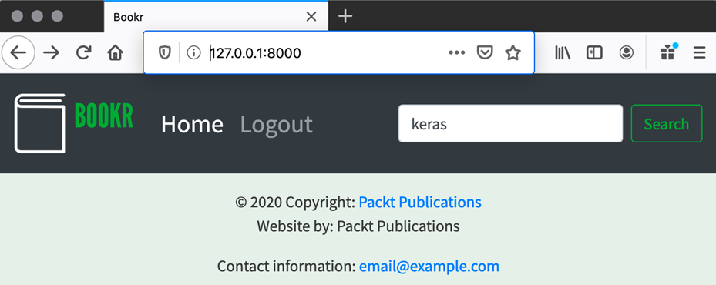

Figure 6.34: Search text entered on the main page

We are still taken to the search results page to see the results (Figure 6.35):

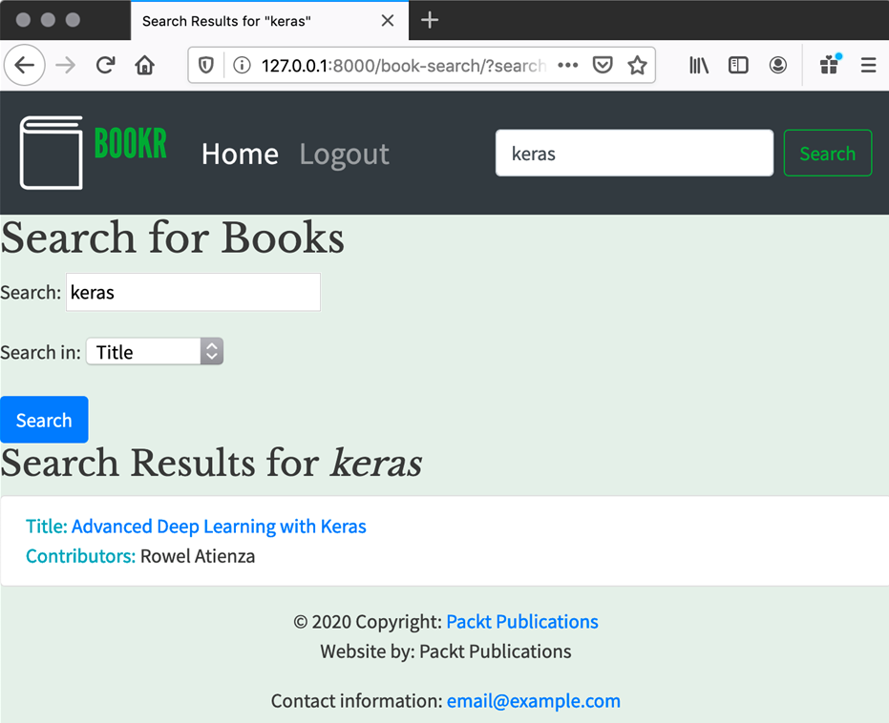

Figure 6.35: The search results (for the title) are the same regardless of which search field was used

Clicking the title link will take you to the book detail page for the book.

Chapter 7: Advanced Form Validation and Model Forms

Activity 7.01: Styling and Integrating the Publisher Form

The following steps will help you complete this activity:

1. In templates/base.html, locate the {% block content %} line. On the line before this, add the opening <div class="container-fluid"> tag. Add a closing </div> after the corresponding {% endblock %}. This section should now look like this:

<div class="container-fluid">

  {% block content %}

  <h1>Welcome to Bookr!</h1>

    {% endblock %}

</div>

1. Add a {% for %} block to iterate over the messages variable. The loop should contain the snippet as shown in step 2 of the activity brief. It should be inside the <div> added in step 1 of the solution but before {% block content %}. The whole container div code should be like this:

<div class="container-fluid">

  {% for message in messages %}

    <div class="alert alert-{% if message.level_tag

    == 'error' %}danger{% else %}{{ message.level_tag

    }}{% endif %}"

  role="alert">

    {{ message }}

  </div>

  {% endfor %}

{% block content %}

  <h1>Welcome to Bookr!</h1>

{% endblock %}

</div>

1. Create a new file inside the reviews/templates/reviews directory:

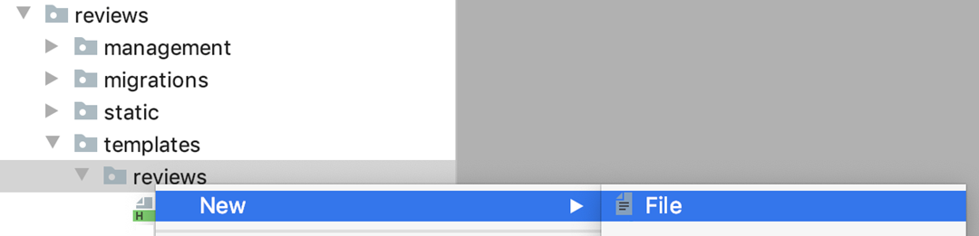

Figure 7.32: Create a new file inside the reviews templates directory

There is no need to select the HTML File option, as we do not need the automatically generated content. Just selecting File is fine.

Name the file instance-form.html.

1. To instance-form.html, add an extends template tag. The template should extend from reviews/base.html, like this:

{% extends 'reviews/base.html' %}

1. In step 13, you will render this template with the context variables form, instance, and model_type. You can write the code in the template to use them already though. Add the {% block title %} and {% endblock %} template tags. Between them, implement the logic to change the text based on instance being None or not:

{% block title %}

{% if instance %}

  Editing {{ model_type }} {{ instance }}

{% else %}

  New {{ model_type }}

{% endif %}

{% endblock %}

1. Add new {% block content %} after the {% endblock %} added in step 5.
2. Add an <h2> element after the {% block content %}. You can reuse the logic from step 5; however, wrap the {{ instance }} display in an <em> element:

{% endblock %} {# from step 5 #}

{% block content %}

<h2>

  {% if instance %}

    Editing {{ model_type }} <em>{{ instance }}</em>

  {% else %}

    New {{ model_type }}

  {% endif %}

</h2>

1. After the closing </h2> tag, add a pair of empty <form> elements. The method attribute should be post:

<form method="post">

</form>

1. Add {% csrf_token %} to the line after the opening <form> tag.
2. Render the form using the {{ form.as_p }} tag. Do this inside the <form> element, after {% csrf_token %}. The code will look like this:

<form method="post">

  {% csrf_token %}

  {{ form.as_p }}

1. After the code added in step 10, add a <button> element. Use similar logic as steps 5 and 7 to change the content of the button based on instance being set. The full button definition is like this:

<button type="submit" class="btn btn-primary">

  {% if instance %}Save{% else %}Create{% endif %}

</button>

Close the {% block %} you opened in step 7 with an {% endblock %}:

</button>

{% endblock %}

1. Open reviews/views.py. Update the second argument to the render call to be "reviews/instance-form.html".
2. Update the context dictionary (the third argument to render). Add the key instance with the value publisher (the Publisher instance that was fetched from the database, or None for a creation). Also add the key model_type, set to the string Publisher. You should retain the key form that was already there. The key method can be removed. After completing the previous steps and this one, your render call should look like this:

render(request, "reviews/instance-form.html",

  {"form": form, "instance": publisher,

    "model_type": "Publisher"})

1. Delete the reviews/templates/form-example.html file.

After completing the activity, you should be able to create and edit Publisher instances. Create a new Publisher by visiting http://127.0.0.1:8000/publishers/new/. The page should look like Figure 7.33:

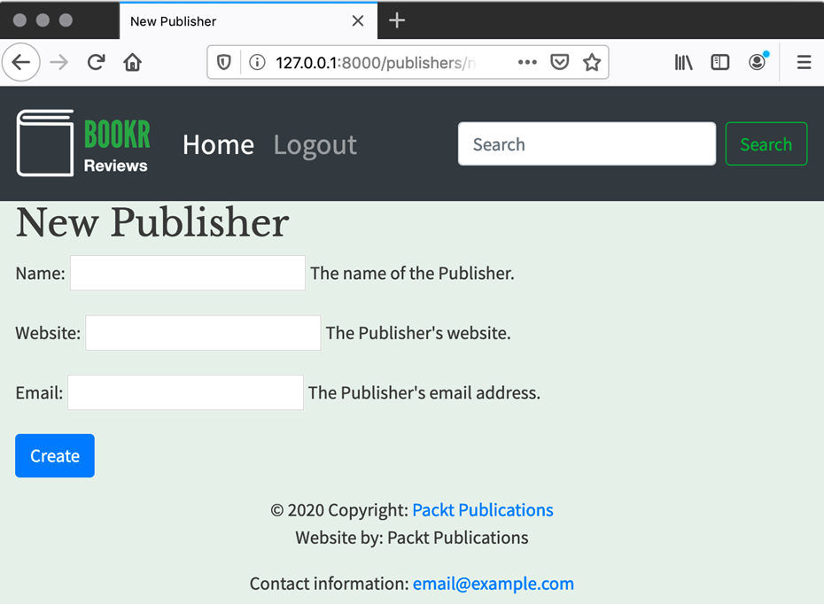

Figure 7.33: The Publisher creation page

Once you have one or more publishers, you can visit http://127.0.0.1:8000/publishers/<id>/, for example, http://127.0.0.1:8000/publishers/1/. Your page should look like Figure 7.34:

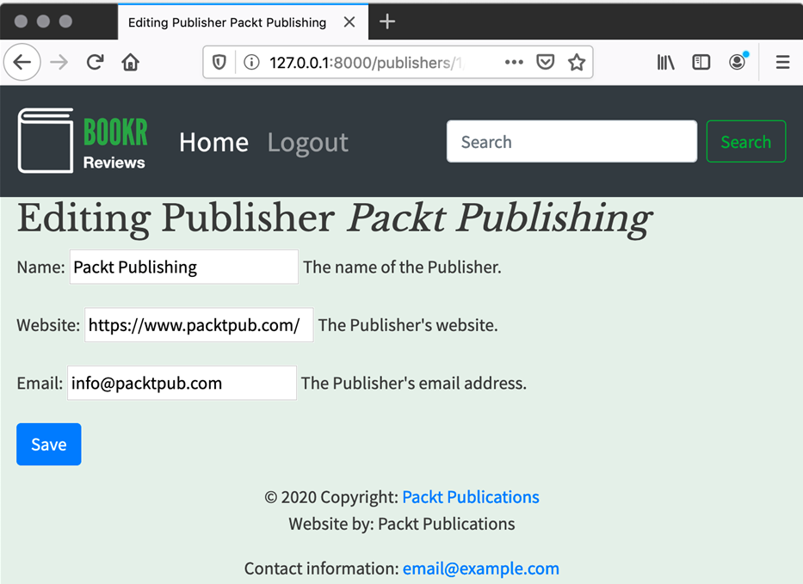

Figure 7.34: The Publisher edit page

After saving a Publisher, whether creating or editing, the success message should be shown in Bootstrap style. This is shown in Figure 7.35:

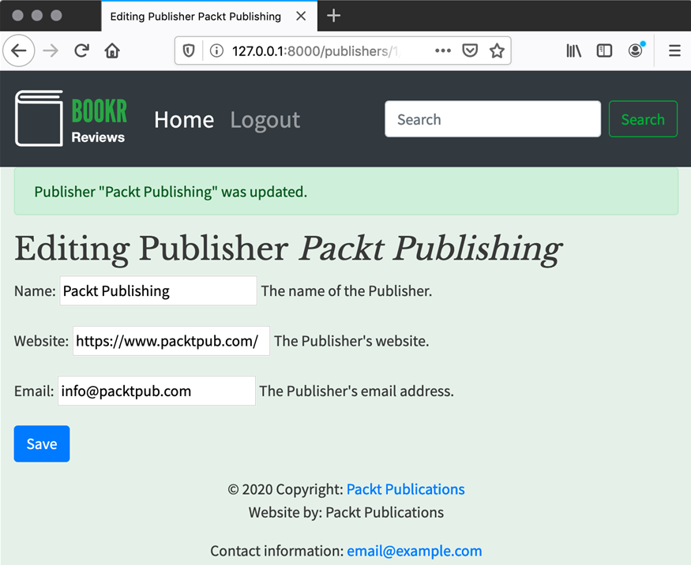

Figure 7.35: Success message rendered as a Bootstrap alert

Activity 7.02: Review Creation UI

The following steps will help you complete this activity:

1. Open forms.py inside the reviews app. At the top of the file, make sure you are importing the Review model. You will already be importing Publisher, like this:

from .models import Publisher

Just import Review as well on this line:

from .models import Publisher, Review

Create a ReviewForm class that inherits from forms.ModelForm. Add a class Meta attribute to set the model to Review:

class ReviewForm(forms.ModelForm):

  class Meta:

    model = Review

Use the exclude attribute on the ReviewForm Meta attribute to exclude the date_edited and book fields so they do not display on the form. ReviewForm should now look like this:

class ReviewForm(forms.ModelForm):

  class Meta:

    model = Review

    exclude = ["date_edited", "book"]

Note that exclude could be a tuple instead, that is, ("date_edited", "book").

Add a rating field – this will override the validation for the model's rating field. It should be of class models.IntegerField, and be instantiated with min_value=0 and max_value=5:

class ReviewForm(forms.ModelForm):

  class Meta:

    # Code truncated

  rating = forms.IntegerField(min_value=0, max_value=5)

The complete forms.py can be found at http://packt.live/2Y6aVwN.

1. Open views.py inside the reviews app. First, make sure to import the Review model. Consider the line:

from .models import Book, Contributor, Publisher

Change it to:

from .models import Book, Contributor, Publisher, Review

Then, create a new view function called review_edit. It should take three arguments: request (required), book_pk (required), and review_pk (optional; it should default to None):

def review_edit(request, book_pk, review_pk=None):

Fetch the Book instance with the get_object_or_404 function, passing in pk=book_pk as a kwarg. Store it in a variable named book:

def review_edit(request, book_pk, review_pk=None):\

    book = get_object_or_404(Book, pk=book_pk)

Fetch the Review being edited only if review_pk is not None. Use the get_object_or_404 function again, passing in the kwargs book_id=book_pk and pk=review_pk. Store the return value in a variable named review. If review_pk is None, then just set review to None:

def review_edit(request, book_pk, review_pk=None):

# Code truncated

    if review_pk is not None:\

        review = get_object_or_404\

                 (Review, book_id=book_pk, pk=review_pk)

    else:

    review = None

Note

Note that since review_pk is unique, then we could fetch the review by just using review_pk. The reason that we use book_pk as well is to enforce the URLs so that a user cannot try to edit a review for a book that it does not belong to. This could get confusing if you could edit any review in the context of any book.

1. Make sure you have imported ReviewForm near the start of the file. You will already have a line importing PublisherForm:

from .forms import PublisherForm, SearchForm

1. Open forms.py inside the reviews app. At the top of the file, make sure you are importing the Review model. You will already be importing Publisher, like this:

from .models import Publisher

Just import Review as well on this line:

from .models import Publisher, Review

Create a ReviewForm class that inherits from forms.ModelForm. Add a class Meta attribute to set the model to Review:

class ReviewForm(forms.ModelForm):

  class Meta:

    model = Review

Use the exclude attribute on the ReviewForm Meta attribute to exclude the date_edited and book fields so they do not display on the form. ReviewForm should now look like this:

class ReviewForm(forms.ModelForm):

  class Meta:

    model = Review

    exclude = ["date_edited", "book"]

Note that exclude could be a tuple instead, that is, ("date_edited", "book").

Add a rating field – this will override the validation for the model's rating field. It should be of class models.IntegerField, and be instantiated with min_value=0 and max_value=5:

class ReviewForm(forms.ModelForm):

  class Meta:

    # Code truncated

  rating = forms.IntegerField(min_value=0, max_value=5)

The complete forms.py can be found at http://packt.live/2Y6aVwN.

1. Open views.py inside the reviews app. First, make sure to import the Review model. Consider the line:

from .models import Book, Contributor, Publisher

Change it to:

from .models import Book, Contributor, Publisher, Review

Then, create a new view function called review_edit. It should take three arguments: request (required), book_pk (required), and review_pk (optional; it should default to None):

def review_edit(request, book_pk, review_pk=None):

Fetch the Book instance with the get_object_or_404 function, passing in pk=book_pk as a kwarg. Store it in a variable named book:

def review_edit(request, book_pk, review_pk=None):

  book = get_object_or_404(Book, pk=book_pk)

Fetch the Review being edited only if review_pk is not None. Use the get_object_or_404 function again, passing in the kwargs book_id=book_pk and pk=review_pk. Store the return value in a variable named review. If review_pk is None, then just set review to None:

def review_edit(request, book_pk, review_pk=None):

  # Code truncated

  if review_pk is not None:\

    review = get_object_or_404(Review, book_id=book_pk, \

                               pk=review_pk)

  else:

    review = None

Note

Note that since review_pk is unique, then we could fetch the review by just using review_pk. The reason that we use book_pk as well is to enforce the URLs so that a user cannot try to edit a review for a book that it does not belong to. This could get confusing if you could edit any review in the context of any book.

1. Make sure you have imported ReviewForm near the start of the file. You will already have a line importing PublisherForm:

from .forms import PublisherForm, SearchForm

Just update it to add the ReviewForm import:

from .forms import PublisherForm, SearchForm, ReviewForm

In the review_edit function, check whether the request.method is equal to the string POST. If so, instantiate the form and pass in request.POST and the Review instance (this was stored in the review variable, and might be None):

def review_edit(request, book_pk, review_pk=None):

  # Code from Steps 5-6 truncated

  if request.method == "POST":

    form = ReviewForm(request.POST, instance=review)

Check the validity of the form using the is_valid() method. If it is valid, then save the form using the save() method. Pass False to save() (this is the commit argument), so that Review is not yet committed to the database. We do this because we need to set the book attribute of Review. Remember the book value is not set in the form, so we set it to Book whose context we are in.

The save() method returns the new or updated Review and we store it in a variable called updated_review:

def review_edit(request, book_pk, review_pk=None):

  # Code truncated

  if request.method == "POST":

    # Code truncated

    if form.is_valid():

      updated_review = form.save(False)

      updated_review.book = book

You can check whether we are creating or editing a Review based on the value of the review variable. This is the Review you fetched from the database – or was set to None. If it is None, then you must be creating a Review (as the view could not load one to edit). Otherwise, you are editing a Review. So, if review is not None, then set the date_edited attribute of updated_review to the current date and time. Make sure you are importing the timezone module from django.utils (you should put this line near the start of the file):

from django.utils import timezone

Then implement the edit/create check (it is an edit if review is not None), and set the date_edited attribute:

def review_edit(request, book_pk, review_pk=None):

  # Code truncated

  if request.method == "POST":

    form = ReviewForm(request.POST, instance=review)

    if form.is_valid():

      # Code truncated

      if review is None:

        pass # This branch is filled in Step 4

      else:

        updated_review.date_edited = timezone.now()

1. Add a call to updated_review.save(), which should happen regardless of an edit or create. Create it after the if/else branch you added in step 3:

def review_edit(request, book_pk, review_pk=None):

  # Code from Steps 5-7 truncated

  if request.method == "POST":

    form = ReviewForm(request.POST, instance=review)

    if form.is_valid():

      # Code truncated

      if review is None:

        pass # This branch is filled next

      else:

        updated_review.date_edited = timezone.now()

        updated_review.save()

1. Now, register the success messages inside the if/else branch created in step 3. Use the messages.success function and the text should be either Review for "<book>" created or Review for "<book>" updated. Regardless of an edit or create, you should return a redirect HTTP response back to the book_detail URL using the redirect function. You'll also need to pass book.pk to this function as it is required to generate the URL:

def review_edit(request, book_pk, review_pk=None):

  # Code truncated

  if request.method == "POST":\

    form = ReviewForm(request.POST, instance=review)

    if form.is_valid():\

      # Code truncated\

    if review is None:\

      messages.success\

      (request, "Review for \"{}\" created."\

                .format(book))\

    else:\

      updated_review.date_edited = timezone.now()\

      messages.success(request, "Review for \"{}\" updated."\

                                .format(book))

    return redirect("book_detail", book.pk)

1. Now create the non-POST branch. This is simply instantiating ReviewForm and passing in the Review instance (again, this might be None):

def review_edit(request, book_pk, review_pk=None):

  # Code truncated

  if request.method == "POST":

    # Code truncated

  else:

    form = ReviewForm(instance=review)

1. The last line of the function is to call the render function and return the result. This code will be called if the method is not POST or the form is not valid.

The arguments to render are request, the instance-form.html template ("reviews/instance-form.html"), and the context dictionary. The context dictionary should contain these keys and values:

form: the form variable

instance: the Review instance (the review variable)

model_type: the string Review

related_instance: the Book instance (the book variable)

related_model_type: the string Book

The render call should look like this:

def review_edit(request, book_pk, review_pk=None):

  # Code truncated

  return render(request, "reviews/instance-form.html",\

                {"form": form, "instance": review,\

                 "model_type": "Review", \

                 "related_instance": book,\

                 "related_model_type": "Book"})

The complete views.py can be found at http://packt.live/35VhF4R.

1. Open instance-form.html in the reviews app's templates directory. Locate the closing </h2> tag, and underneath add an if template tag. It should check that both related_instance and related_model_type are set. Its contents should be a <p> element displaying For {{ related_model_type }} <em>{{ related_instance }}</em>. The code you add should look like this:

{% if related_instance and related_model_type %}

  <p>For {{ related_model_type }} <em>{{    related_instance }}</em></p>

{% endif %}

The complete instance-form.html can be found at http://packt.live/3bSyd0U.

1. Open the reviews app's urls.py file. Add these two mappings to urlpatterns:

path('books/<int:book_pk>/reviews/new/',

      views.review_edit, name='review_create'),\

       path('books/<int:book_pk>/reviews/<int:review_pk>/', \

            views.review_edit, name='review_edit'),

Note that the order of URL patterns does not matter in this case, so you may have put the new maps in a different place in the list. This is fine. The complete urls.py file can be found at http://packt.live/2XSxmoX.

1. Open book_detail.html. Locate the {% endblock %} closing template tag for the content block. This should be the last line of the file. On the line before this, add a link using an <a> element. Its href attribute should be set using the url template tag, with the name of the URL as defined in the map: {% url 'review_create' book.pk %}. The classes on <a> should be btn and btn-primary. The full link code is:

<a class="btn btn-primary" href="{% url   
 'review_create' book.pk %}">Add Review</a>

1. Locate the reviews iterator template tag {% for review in reviews %}, and then its corresponding {% endfor %} closing template tag. Before this closing template tag is a closing </li>, which closes the list item that contains all the Book data. You should add the new <a> element before the closing </li>. Generate the href attribute content using the url template tag and the name of the URL defined in the map: {% url 'review_edit' book.pk review.pk %}. The full link code is:

<a href="{% url 'review_edit' book.pk review.pk %}">  
 Edit Review</a>

The complete book_detail.html file can be found at http://packt.live/3irIySR.

Start the Django dev server if it is not already running. The first URL assumes you already have at least one book in your database. Visit http://127.0.0.1:8000/books/1/. You should see your new Add Review button:

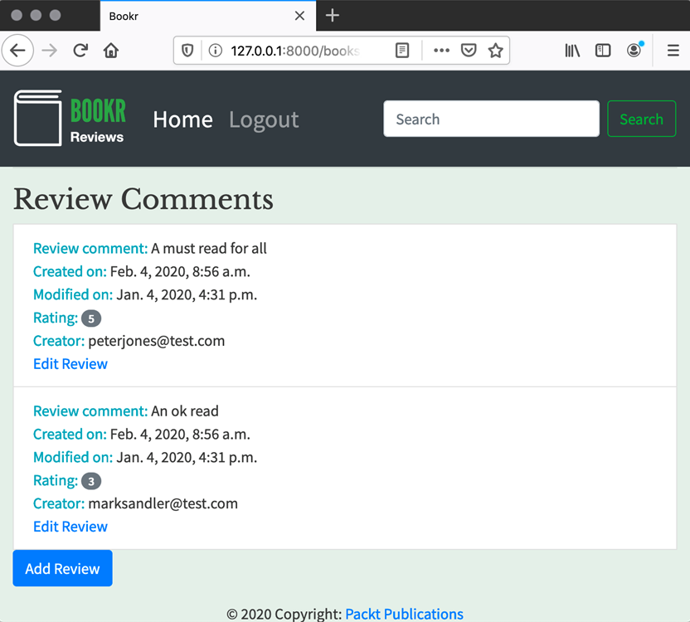

Figure 7.36: Book Detail page with an Add Review button

Clicking it will take you to the Review creation view for the book. If you try submitting the form with missing fields, your browser should use its validation rules to prevent submission (Figure 7.37):

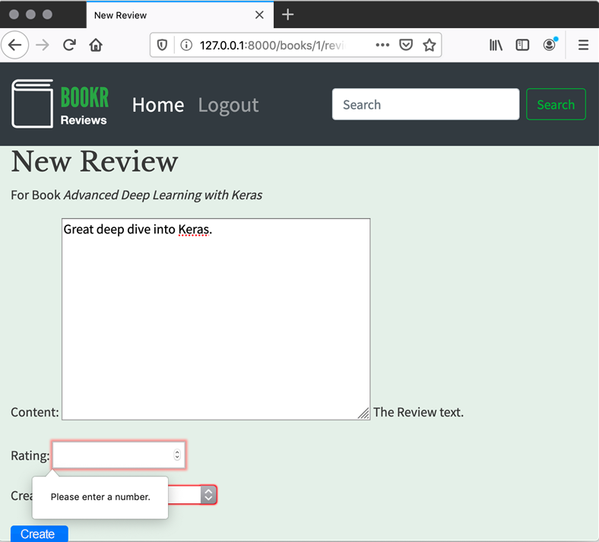

Figure 7.37: Review creation form with missing Rating

After creating the form, you are taken back to the Book Details page, and you can see the review you added, along with a link to go back and edit the Review:

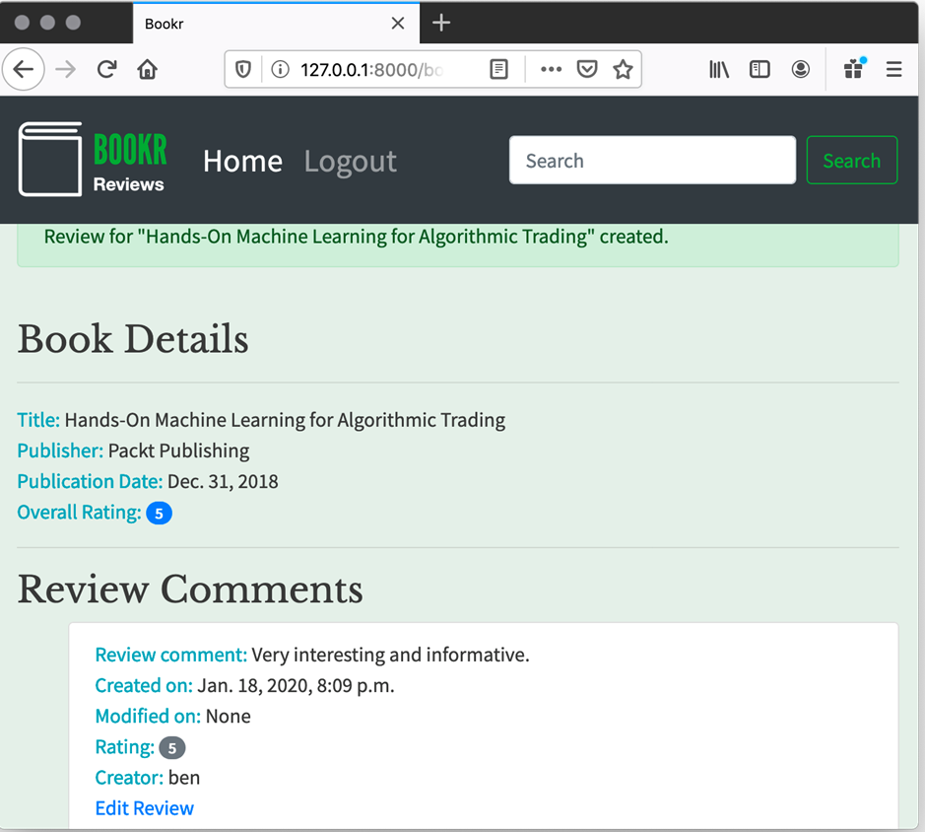

Figure 7.38: New review added, with Edit Review link

Click the Edit Review link and make some changes to the form. Save it, and you will be redirected back to the Book Details view again – this time, the Modified on field should show the current date and time (see Figure 7.39):

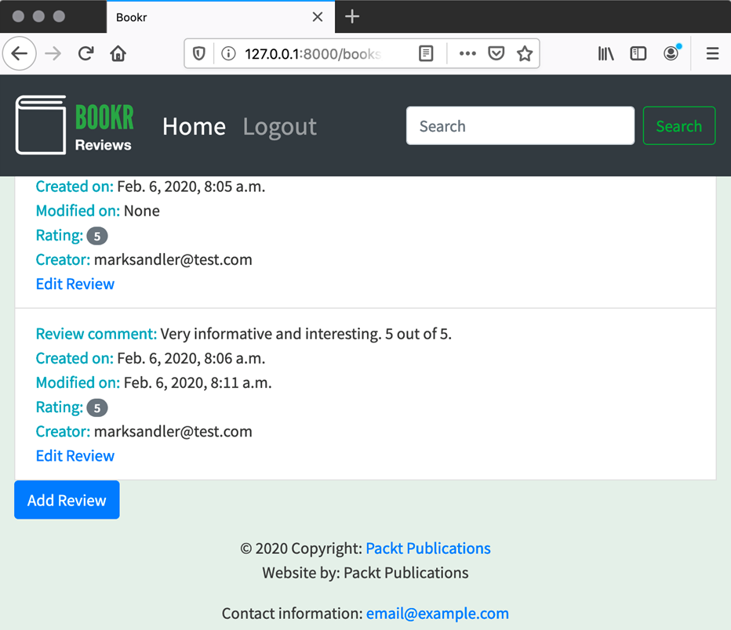

Figure 7.39: Modified on date populated after editing a review

In this activity, we used a ModelForm to add a page where users could save a review. Some custom validation rules on ModelForm ensured that the review's rating was between 0 and 5. We also created a generic instance form template that can render different types of ModelForm.

Chapter 8: Media Serving and File Uploads

Activity 8.01: Image and PDF Uploads of Books

The following steps will help you complete this activity:

1. Open the project's settings.py file. Down the bottom, add these two lines to set the MEDIA_ROOT and MEDIA_URL:

MEDIA_ROOT = os.path.join(BASE_DIR, 'media')

MEDIA_URL = '/media/'

The file can now be saved and closed. Your file should now look like this: http://packt.live/3p1wABV.

1. Open urls.py. Above the other imports, add these two lines:

from django.conf import settings

from django.conf.urls.static import static

These will import the Django settings and the built-in static view, respectively.

Then, after your urlpatterns definition, conditionally add a map to the static view if DEBUG is true:

if settings.DEBUG:

    urlpatterns += static(settings.MEDIA_URL, \

                          document_root=settings.MEDIA_ROOT)

Save and close urls.py. It should look like this: http://packt.live/2LCiQPO.

1. Open the reviews app's models.py. To the book model, add the cover field attribute with this code:

cover = models.ImageField(null=True, blank=True, \

                          upload_to="book_covers/")

This will add an ImageField that is not required, and stores uploads to the book_covers subdirectory of the MEDIA_ROOT.

The sample field is added in a similar manner:

sample = models.FileField(null=True, blank=True, \

                          upload_to="book_samples/")

This field is also not required, and allows uploads of any file type, storing them to the book_samples subdirectory of MEDIA_ROOT.

Save the file. It should look like this now: http://packt.live/3szFskq.

1. Open a terminal and navigate to the Bookr project directory. Run the makemigrations management command:

python3 manage.py makemigrations

This will generate the migration to add the cover and sample fields to the Book.

You should see similar output to this:

(bookr)$ python3 manage.py makemigrations

Migrations for 'reviews':

  reviews/migrations/0006_auto_20200123_2145.py

    - Add field cover to book

    - Add field sample to book

Then, run the migrate command to apply the migration:

python3 manage.py migrate

You should see similar output to this:

(bookr)$ python3 manage.py migrate

Operations to perform:

  Apply all migrations: admin, auth, contenttypes, reviews, sessions

Running migrations:

  Applying reviews.0006_auto_20200123_2145... OK

1. Back in PyCharm, open the reviews app's forms.py. You first need to import the Book model at the top of the file. Consider the following line:

from .models import Publisher, Review

Change this line to:

from .models import Publisher, Review, Book

Then, at the end of the file, create a BookMediaForm class as a subclass of forms.ModelForm. Using the class Meta attribute, set the model to Book, and fields to ["cover", "sample"]. Your completed BookMediaForm should look like this:

class BookMediaForm(forms.ModelForm):

    class Meta:

        model = Book

        fields = ["cover", "sample"]

You can save and close this file. The complete file should look like this: http://packt.live/35Qqm0k.

1. Open the reviews app's views.py. Import the image manipulation libraries (refer to step 4 of Exercise 8.05, Image Uploads using Django Forms to install Pillow, if you haven't already installed it in your virtual environment):

from io import BytesIO

from PIL import Image

from django.core.files.images import ImageFile

You'll also need to import the BookMediaForm class you just created. Change the import line from this:

from .forms import PublisherForm, SearchForm, ReviewForm

To this:

from .forms import PublisherForm, SearchForm, ReviewForm, BookMediaForm

At the end of the file, create a view function called book_media, which accepts two arguments – request and pk:

def book_media(request, pk):

1. The view will follow a pattern similar to what we have done before. First, fetch the Book instance with the get_object_or_404 shortcut:

def book_media(request, pk):

    book = get_object_or_404(Book, pk=pk)

If the request.method is POST, then instantiate the BookMediaForm with request.POST, request.FILES, and the Book instance:

    if request.method == "POST":

        form = BookMediaForm(request.POST, request.FILES, \

                             instance=book)

Check if the form is valid, and if so, save the form. Make sure to pass False as the commit argument to save, since we want to update and resize the image before saving the data:

        if form.is_valid():

            book = form.save(False)

Create a reference to the uploaded cover. This is mostly just as a shortcut, so you don't have to type form.cleaned_data["cover"] all the time:

            cover = form.cleaned_data.get("cover")

Next, do the image resize. Use the cover variable as a reference to the uploaded file. You only want to perform operations on the image if it is not None:

            if cover:

This code is similar to that demonstrated in the section Writing PIL Images to ImageField. You should refer to that section for a full explanation. Essentially, you are using PIL to open the uploaded image file, then resizing it so its maximum dimension is 300 pixels. You then write the data to BytesIO and save it on the model using a Django ImageFile:

                image = Image.open(cover)

                image.thumbnail((300, 300))

                image_data = BytesIO()

                image.save(fp=image_data, \

                           format=cover.image.format)

                image_file = ImageFile(image_data)

                book.cover.save(cover.name, image_file)

After doing the updates, save the Book instance. The form might have been submitted with the clear option set on the cover or sample fields, so this will clear those fields in that case:

            book.save()

Then we register the success message and redirect back to the book_detail view:

            messages.success(request, "Book \"{}\"

         was successfully updated.".format(book))

            return redirect("book_detail", book.pk)

This else branch is for the non-POST request case. Instantiate the form with just the Book instance:

    else:

        form = BookMediaForm(instance=book)

1. The last thing to do in book_media is to render instance-form.html and pass the instance (the book variable), form (the form variable), model_type (the Book string), and is_file_upload (True) in the context dictionary:

return render(request, "reviews/instance-form.html",\

              {"instance": book, "form": form,\

               "model_type": "Book","is_file_upload":True})

You will use the is_file_upload flag in the next step. Once you have completed steps 6 to 8, your book_media function should look like http://packt.live/3ipgaRe:

1. Open the instance-form.html file inside the reviews app's templates directory. Use the if template tag to add the enctype="multipart/form-data" attribute to the form, if is_file_upload is True:

<form method="post" {% if is_file_upload %}  
 enctype="multipart/form-data"{% endif %}>

    {% csrf_token %}

    {{ form.as_p }}

    <button type="submit" class="btn btn-primary">

        {% if instance %}Save{% else %}Create{% endif %}

    </button>

</form>

Save and close the file. It should look like this: http://packt.live/2XVplzr.

1. Open the reviews app's urls.py. In urlpatterns, add a mapping like this:

urlpatterns = […\

               path('books/<int:pk>/media/', \

                     views.book_media, name='book_media')

Your urlpatterns should look like this: http://packt.live/39M6AnE.

Remember that the order of your urlpatterns might be different.

You should now be able to start the Django dev server, if it's not already running, then view the Book Media page in your browser, for example, at http://127.0.0.1:8000/books/2/media/. The following figure shows this:

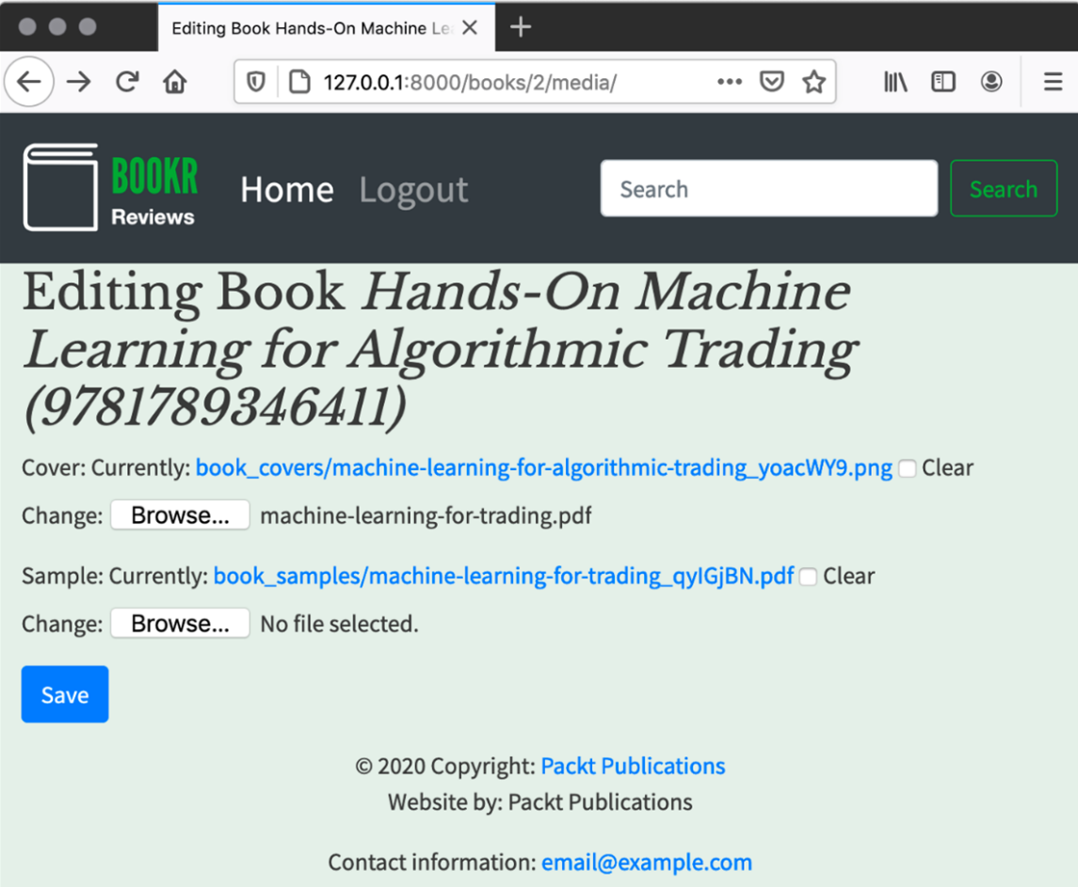

Figure 8.35: BookMediaForm with existing values

Try uploading some files and checking to see them in the media directory. Check the sizes of the images that you upload too, and notice they have been resized.

Activity 8.02: Displaying Cover and Sample Links

The following steps will help you complete this activity:

1. Open the reviews app's book_detail.html template. After the first <hr> tag, add an if template tag that checks for the presence of book.cover. Inside it, put your <img> tag. Its src should be set from book.cover.url. Add a <br> tag after the <img> tag. The code you add should look like this:

{% if book.cover %}

      <img src="{{ book.cover.url }}">

      <br>

{% endif %}

1. Perform a similar check for the presence of book.sample, and if it is set, display an info line similar to the existing ones. The <a> tag's href attribute should be set using book.sample.url. The code you add here should look like this:

{% if book.sample %}

      <span class="text-info">Sample: </span>  
 <span><a href="{{ book.sample.url }}">Download</a></span>

      <br>

{% endif %}

1. Scroll to the end of the file where there the Add Review link is located. Underneath it, add another <a> tag, and generate its href content using the url template tag. This should use 'book_media' and book.pk as its arguments. Make sure you include the same classes on the <a> tag as the existing Add Review link, so that the link displays as a button.

This is the code you should add:

<a class="btn btn-primary" href="  
 {% url 'book_media' book.pk %}">Media</a>

Once again, here is the code that was added in context with the existing code. The complete file should look like this: http://packt.live/38W5dDK.

Now you can start the Django dev server if it is not already running. You can view a Book Details page (for example, http://127.0.0.1:8000/books/1/) and then click on the new Media link to get to the media page for the Book. After uploading a cover image or sample file, you will be taken back to the Book Details page where you will see the cover and a link to the sample file (Figure 8.36):

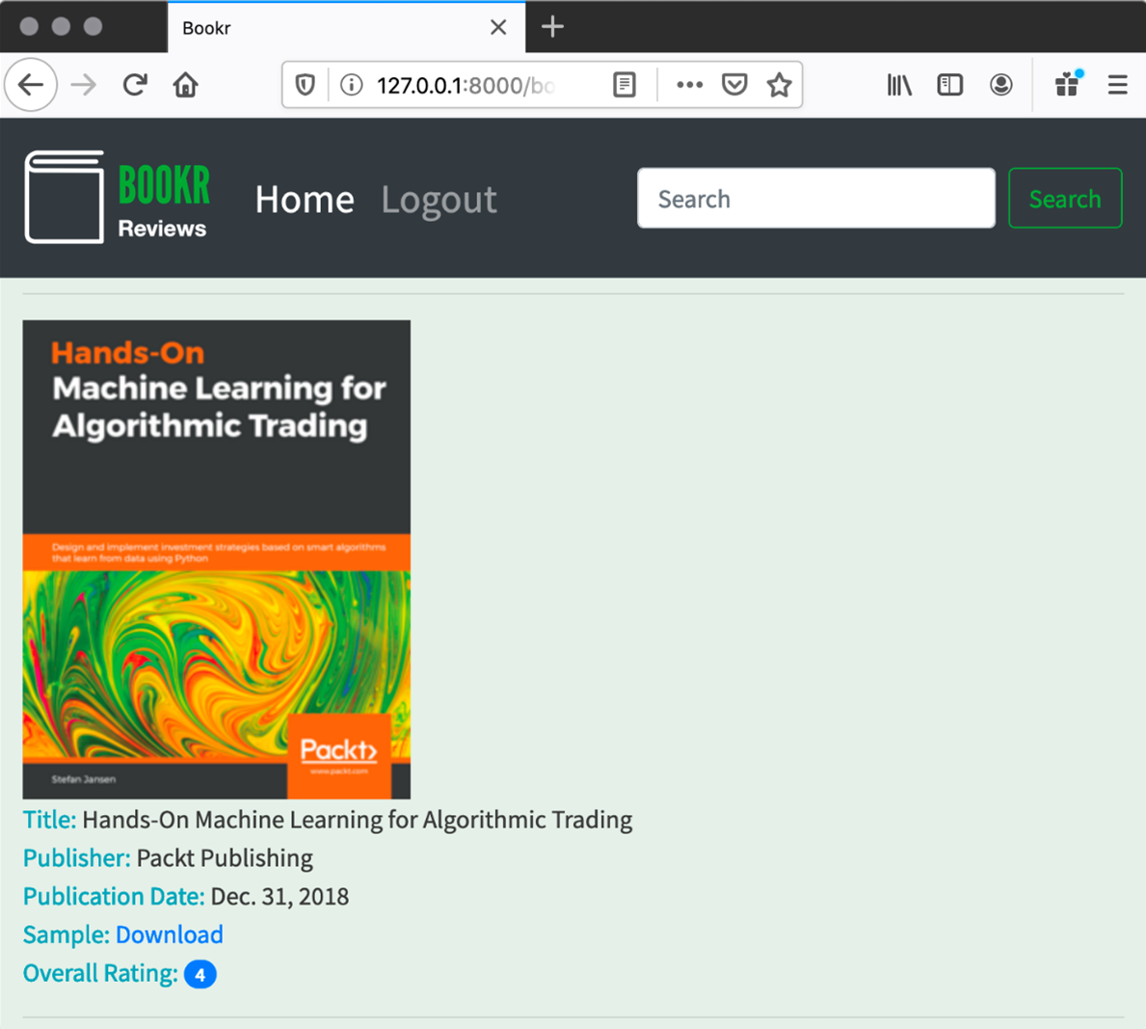

Figure 8.36: Book cover and sample link displayed

In this activity, we added the display of a book's cover image and a link to its sample to the Book Details page, as well as a link from the Book Details page to the Book Media page. This enhances the look of Bookr by showing an image and gives readers a more in-depth look into the Book that was reviewed.

Chapter 9: Sessions and Authentication

Activity 9.01: Authentication-Based Content Using Conditional Blocks in Templates

The following steps will help you complete this activity:

1. On the book_detail template, as found in the reviews/templates/reviews/book_detail.html file, hide the Add Review and Media buttons from non-authenticated users. Wrap the two links in an if user.is_authenticated … endif block:

{% if user.is_authenticated %}

        <a class="btn btn-primary" href="{% url 'review_create' book.pk   
 %}">Add Review</a>

        <a class="btn btn-primary" href="{% url 'book_media' book.pk   
 %}">Media</a>

{% endif %}

1. In that same file, wrap the header in an if user.is_authenticated … endif block:

{% if user.is_authenticated %}

    <h3>Be the first one to write a review.</h3>

{% endif %}

1. In the same template, make the Edit Review link only appear for staff or the user that wrote the review. The conditional logic for the template block is very similar to the conditional logic that we used in the review_edit view in Exercise 9.03, Adding Authentication Decorators to the Views. We can make use of the is_staff property of the user. We need to compare the user's id with that of the review's creator to determine that they are the same user:

{% if user.is_staff or user.id == review.creator.id %}

    <a href="{% url 'review_edit' book.pk review.pk %}">Edit Review</a>

{% endif %}

1. From the templates directory in the main bookr project, modify base.html so that it displays the currently authenticated user's username to the right of the search form in the header, linking to the user profile page. Again, we can use the user.is_authenticated attribute to determine whether the user is logged in and the user.username attribute for the username. This conditional block follows the search form in the header:

{% if user.is_authenticated %}

  <a class="nav-link" href="/accounts/profile">User:

  {{ user.username }}</a>

{% endif %}

By tailoring content to a user's authentication status and permissions, we are creating a smoother and more intuitive user experience. The next step is to store user-specific information in sessions so that the project can incorporate the user's preferences and interaction history.

Activity 9.02: Using Session Storage for the Book Search Page

The following steps will help you complete this activity:

1. Edit the book_search view to retrieve search_history from the session in the reviews/views.py file:

def book_search(request):

    search_text = request.GET.get("search", "")

    search_history = request.session.get('search_history', [])

1. If the form has received valid input and a user is authenticated, append the search option, search_in, and search text, search, to the session's search_history list:

    if form.is_valid() and form.cleaned_data["search"]:

        search = form.cleaned_data["search"]

        search_in = form.cleaned_data.get("search_in") or "title

        if search_in == "title":

            …

        if request.user.is_authenticated:

            search_history.append([search_in, search])

            request.session['search_history'] = search_history

1. In the case that the form hasn't been filled (for example, when the page is first visited), render the form with the previously used search option selected, either Title or Contributor:

    elif search_history:

        initial = dict(search=search_text,

                     search_in=search_history[-1][0])

        form = SearchForm(initial=initial)

The complete book_search function should look like this:

bookr/reviews/views.py

1  def book_search(request):

2      search_text = request.GET.get("search", "")

3      search_history = request.session.get('search_history', [])

4

5      form = SearchForm(request.GET)

6

7      books = set()

8

9      if form.is_valid() and form.cleaned_data["search"]:

You can view the complete code at http://packt.live/3oXpApJ

1. In the profile template, templates/profile.html, include an additional infocell division for Search History, as follows:

<style>

…

</style>

  <div class="flexrow" >

    <div class="infocell" >

      <p>Profile</p>

      …

    </div>

    <div class="infocell" >

      <p>Viewed Books</p>

      …

    </div>

    <div class="infocell" >

      <p>Search History</p>

      …

    </div>

</div>

1. List the search history as a series of links to the book search page. The complete Search History division will look like this:

  <div class="infocell" >

    <p>Search History</p>

    <p>

      {% for search_in, search in request.session.search_history %}

      <a href="{% url 'book_search'

               %}?search={{search|urlencode}}&search_in={{ search_in}}" >

            {{ search }} ({{ search_in }})</a>

      <br>

      {% empty %}

        No search history found.

      {% endfor %}

    </p>

  </div>

Once you have completed these changes and made some searches, the profile page will look something like this:

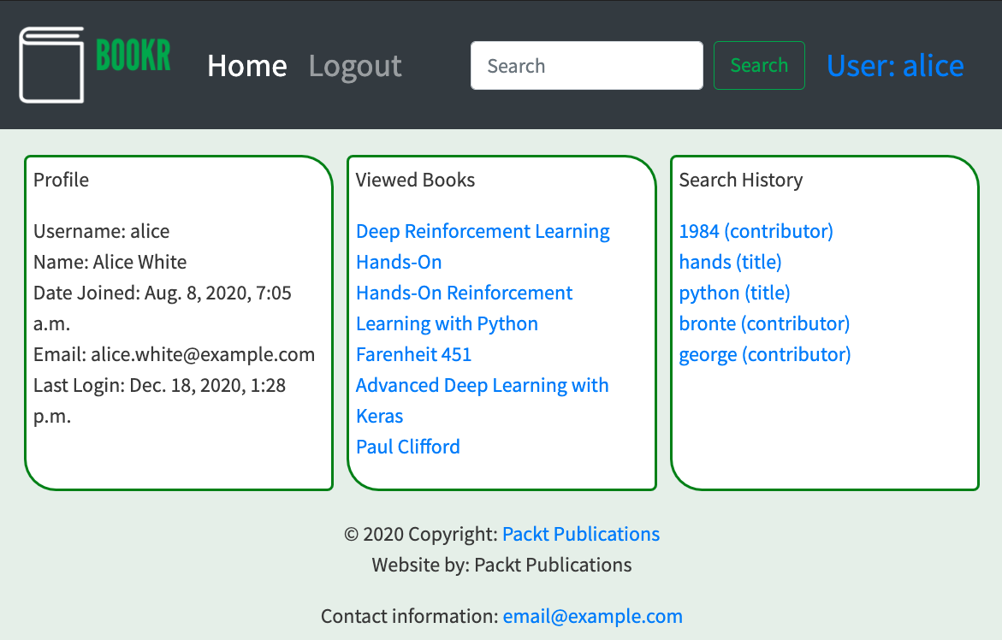

Figure 9.21: The profile page with the Search History infocell

If it is not already running, you will need to start the Django server using this command:

python manage.py runserver

To view the profile page, you will need to log in and click the User link in the top-right corner of the webpage.

Keeping form preferences in session data is a useful technique for improving user experience. We naturally expect settings to still be the way that we last saw them and it is frustrating to find all the values cleared on a complicated form that we are using repeatedly.

Chapter 10: Advanced Django Admin and Customizations

Activity 10.01: Building a Custom Admin Dashboard with Built-In Search

1. As a first step, create an admin site application in the bookr project (if not created already), which you will use to build our custom admin application. To create this app, run the following command from the base directory of your project:

python manage.py startapp bookr_admin

1. With the admin site application now created, open the admin.py file under the bookr_admin directory and replace its contents with the following code:

from django.contrib import admin

class BookrAdmin(admin.AdminSite):

  site_header = "Bookr Administration Portal"

  site_title = "Bookr Administration Portal"

  index_title = "Bookr Administration"

In the preceding code sample, you first created a class named BookrAdmin, which inherits from the AdminSite class provided by Django's admin module. You have also customized the site properties to make the admin panel display the text you want. Your admin.py file should look like this: https://github.com/PacktPublishing/Web-Development-with-Django-Second-Edition/tree/main/Chapter10/Activity10.01/bookr_admin/admin.py.

1. Now, with the class created, the next step involves making sure that your application will be recognized as a default admin site application. You should have already done this in Exercise 10.02, Overriding the Default Admin Site. Consequently, your apps.py file under the bookr_admin directory should look like this:

from django.contrib.admin.apps import AdminConfig

class BookrAdminConfig(AdminConfig):

    default_site = 'bookr_admin.admin.BookrAdmin'

If not, replace the contents of the file with the code provided in the preceding code block.

The apps.py file should look like this: https://github.com/PacktPublishing/Web-Development-with-Django-Second-Edition/tree/main/Chapter10/Activity10.01/bookr_admin/apps.py.

1. The next step involves making sure that Django uses bookr_admin as the administration application. To check this, open the settings.py file under bookr and validate if the following line is present in the INSTALLED_APPS section. If not, add it at the top of the section:

'bookr_admin.apps.BookrAdminConfig'

Your INSTALLED_APPS section should resemble the one shown here:

INSTALLED_APPS = [

    'bookr_admin.apps.BookrAdminConfig',

    'django.contrib.auth',

    'django.contrib.contenttypes',

    'django.contrib.sessions',

    'django.contrib.messages',

    'django.contrib.staticfiles',

    'reviews'

]

1. Once the settings.py file is configured to use bookr_admin, the default admin site should now be replaced by the instance you provided. To validate if the changes you made worked, run the following command:

python manage.py runserver localhost:8000

Then, navigate to http://localhost:8000/admin. You will see a page that resembles the one shown here:

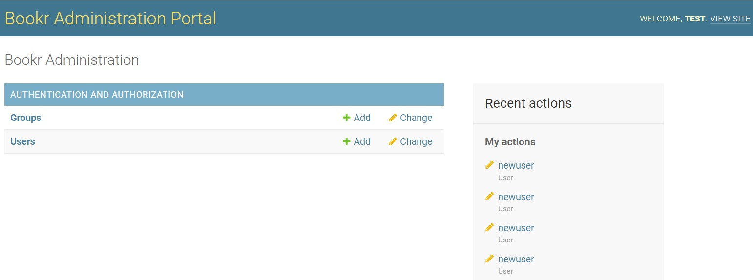

Figure 10.9: Bookr Administration Portal landing page

Note

The preceding screen will vary depending on the version of the admin.py file (in the reviews app) you are using. If you're continuing from Chapter 9, Sessions and Authentication, unlike in Figure 10.9, the Book model should be visible. If it is, you can skip step 6. Still, it is recommended that you use that step to cross-validate your code.

You now have a custom admin site up and running.

1. If there are no models registered to your admin site, the list of books still won't show up. To now view the list of books in the admin panel, open the admin.py file under the reviews app directory and validate whether the highlighted code blocks are present therein. If not, add them:

from django.contrib import admin

from reviews.models import (Publisher, Contributor, Book,

        BookContributor, Review)

# Register your models here.

admin.site.register(Publisher)

admin.site.register(Contributor, ContributorAdmin)

admin.site.register(Book)

In the preceding code sample, you imported the Book model from our reviews app and registered it with the admin site. The Book model contains the records of all of the books that you have registered in Bookr, along with the details of their publishers and publication dates.

Following this change, if you reload the admin site, you will see that the Book model starts to show up in the admin panel, and clicking it should show you something similar to the following screenshot:

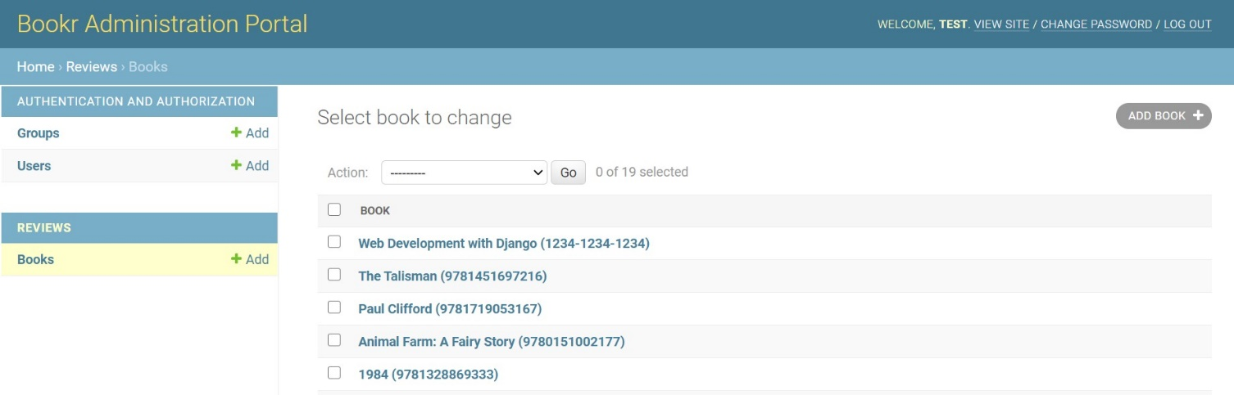

Figure 10.10: Bookr Administration Portal Books model view

1. Now, to make sure that Bookr admins can search books by their name or the publisher's name in the admin site, you need to create a ModelAdmin interface for the Book model such that the behavior of the Book model can be customized inside the admin site. To do this, reopen the admin.py file under the reviews app directory and add the following class to the file:

class BookAdmin(admin.ModelAdmin):

    model = Book

    list_display = ('title', 'isbn', 'get_publisher', 'publication_date')

    search_fields = ['title', 'publisher__name']

    def get_publisher(self, obj):

      return obj.publisher.name

The preceding class defines the ModelAdmin interface for our Book model. Inside this class, we define a couple of properties.

You begin by mentioning the model to which this ModelAdmin interface applies by specifying the model property to point to our Book model:

model = Book

The next thing to do is to select the fields that are to be shown in the admin site table when someone clicks the Book model. This is done by setting the list_display property to the set of fields to display:

list_display = ('title', 'isbn', 'get_publisher', 'publication_date')

As you can see, you selected the title, isbn, and publication_date fields from the Book model. But what is this get_publisher field?

The list_display property can take an input that includes the list of attributes of the Model class, as well as the name of any callable, and print the value returned by the callable. In this case, get_publisher is a callable defined inside the BookAdmin class.

The next thing you did is to add a search_fields property and point it to use the title and publisher__name fields. This adds the capability in the admin site to search for books either by their title or by the name of the publisher.

The last thing you did in the class involved defining our get_publisher() callable. This callable is responsible for returning the name of the publisher from a book record. This callable is required because Publisher is mapped as a foreign key inside the Book model, and hence you need to retrieve the name field of the publisher using the object reference you obtained.

The callable takes a single parameter, obj, which refers to the current object being parsed (the method is called for every object that we iterate upon), and returns the name field from the publisher object inside our result:

def get_publisher(self, obj):

  return obj.publisher.name

1. Once the preceding step is complete, you need to make sure that ModelAdmin is assigned to the Book model for use in our admin site. To do this, edit the admin.site.register call inside the admin.py file under the reviews app to make it look like the one shown here:

admin.site.register(Book, BookAdmin)

The admin.py file under the reviews app should now look like this: /PacktPublishing/Web-Development-with-Django-Second-Edition/tree/main/Chapter10/Activity10.01/reviews/admin.py.

1. Now that you are done with making changes, let's run the application by running the following command:

python manage.py runserver localhost:8000

Then, navigate to http://localhost:8000/admin.

Once you are on the page, you can click on the Book model being shown and it should redirect you to a page that should resemble the following screenshot:

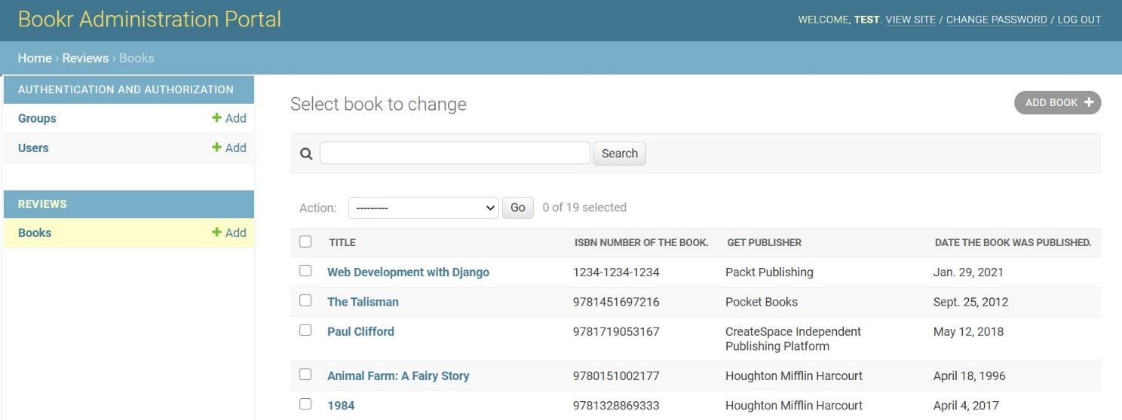

Figure 10.11: Book model customizations in the Bookr administration view

If you notice the difference between our earlier page and the page we just loaded, we can see that the page now lists the fields that we selected in our ModelAdmin class definition, as well as providing us with an option to search the books. We can insert either the name of a book or its publisher in the search box. Upon selecting a book, we have an option to either modify or delete it:

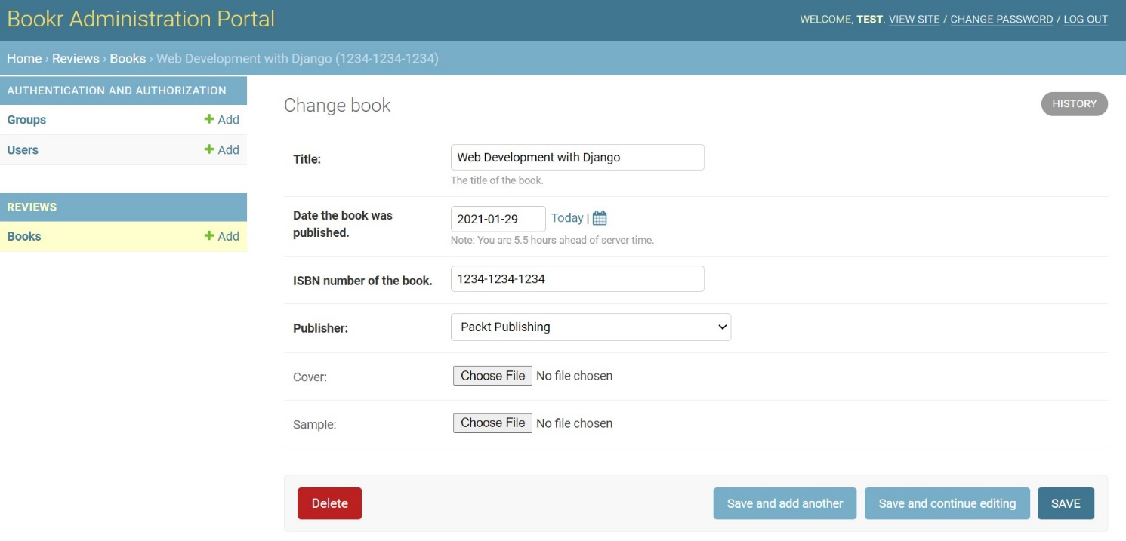

Figure 10.12: Deleting a book record using the administration portal

If you are getting results that resemble those in Figure 10.12, you have successfully completed this activity.

Chapter 11: Advanced Templating and Class-Based Views

Activity 11.01: Rendering Details on the User Profile Page Using Inclusion Tags

The following steps will help you complete this activity:

1. For this activity, you are going to reuse a lot of work that you have done in the previous chapters regarding building the Bookr app. Instead of recreating things from scratch, let's focus on those areas that are unique to this activity.

Now, to begin introducing a custom inclusion tag, which will be used to render the list of books read by our user in the user profile, first create a directory named templatetags under the reviews app directory and then create a new file named profile_tags.py inside it.

1. With the file creation complete, the next step is to build the template tag. For this, open the profile_tags.py file, which you created in step 1, and add the following code to it:

from django import template

from reviews.models import Review

register = template.Library()

@register.inclusion_tag('book_list.html')

def book_list(username):

     """Render the list of books read by a user.

    :param: str username The username for whom the books

        should be fetched

    :return: dict of books read by user

    """

    reviews = Review.objects.filter(creator__username__contains=username)

    book_list = [review.book.title for review in reviews]

    return {'books_read': book_list}

In this code, you did a few interesting things. Let's walk through them step by step.

You first imported Django's template module, which will be used to set up the template tags library:

from django import template

After that, you imported the model, which is used to store all the reviews by the user. This is done based on the assumption that a review is written by a user only for the books that they have read, and hence you used this Review model to derive the books read by a user:

from reviews.models import Review

Next, you initialized an instance of the template library. This instance will be used to register your custom template tags with Django's templating system:

register = template.Library()

Finally, you created the custom template tag named book_list. This tag will be an inclusion tag because, based on the data it generates, it renders its own template to show the results of the query for the books read based on the username of the user.

To render the results, you used the template code located inside the book_list.html template file:

@register.inclusion_tag('book_list.html')

def book_list(username):

Inside the template tag, you first retrieved all the reviews provided by the user:

reviews = Review.objects.filter(creator__username__contains=username)

Since the user field is mapped to the Review model as a foreign key, you used the creator attribute (which maps to the User model) from the Review object and then filtered based on the username.

Once you had the list of reviews, you then created a list of books read by the user by iterating upon the objects returned from the database:

book_list = [review.book.title for review in reviews]

Once this list was generated, you wrote the following line to return a template context object. This is nothing but a dictionary of the book_list variable you can now render inside the template:

return {'books_read': book_list}

In this case, you will be able to access the list of books read by referencing the books_read variable inside the template.

1. With the template tag created, you can now move on to create the book_list template (if not already created in the previous exercises). In case you have created it already, you can skip to step 4. For this, create a new file named book_list.html under the templates directory of the reviews app. Once this file is created, add the following code inside it:

<p>Books read</p>

<ul>

  {% for book in books_read %}

  <li>{{ book }}</li>

  {% endfor %}

</ul>

This is a plain HTML template where you are rendering the list of books as provided by the custom inclusion tag that we built in step 2.

As you can see, you have created a for loop that iterates over the books_read variable provided by the inclusion tag, and then, for every element inside the books_read variable, you create a new list item.

1. With the book_list template completed, it's time to integrate the template tag into the user profile page. To do this, open the profile.html (responsible for rendering the user profile page) file located under the templates directory present in the root directory of the project and make the following changes:

After the following command:

{% extends "base.html" %}

You need to load the template tag by adding the following statement:

{% load profile_tags %}

This will load the tags from the profile_tags file. The order of these statements is important because Django requires that the extends tag comes first before any other tag in the template file. Failing to do so will result in a template rendering failure while trying to render the template.

1. Now, with the tag loaded, add the book_list tag. For this, replace the code under the profile.html file inside the templates directory with the following code:

{% extends "base.html" %}

{% load profile_tags %}

{% block title %}Bookr{% endblock %}

{% block heading %}Profile{% endblock %}

{% block content %}

  <ul>

    <li>Username: {{ user.username }} </li>

    <li>Name: {{ user.first_name }} {{ user.last_name }}</li>

    <li>Date Joined: {{ user.date_joined }} </li>

    <li>Email: {{ user.email }}</li>

    <li>Last Login: {{ user.last_login }}</li>

    <li>Groups: {{ groups }}{% if not groups %}None{% endif %} </li>

  </ul>

  {% book_list user.username %}

{% endblock %}

The code segment marked in bold instructs Django to use the book_list custom tag to render the list of books read by the user.

1. With this, you have successfully built the custom inclusion tag and integrated it with the user profile page. To see how your work renders on the browser, run the following command:

python manage.py runserver localhost:8080

Then, navigate to your user profile by visiting http://localhost:8080/. Once you are on your user profile, and if you have added any book to the list of books reviewed, you will see a page that resembles the one shown in the following screenshot:

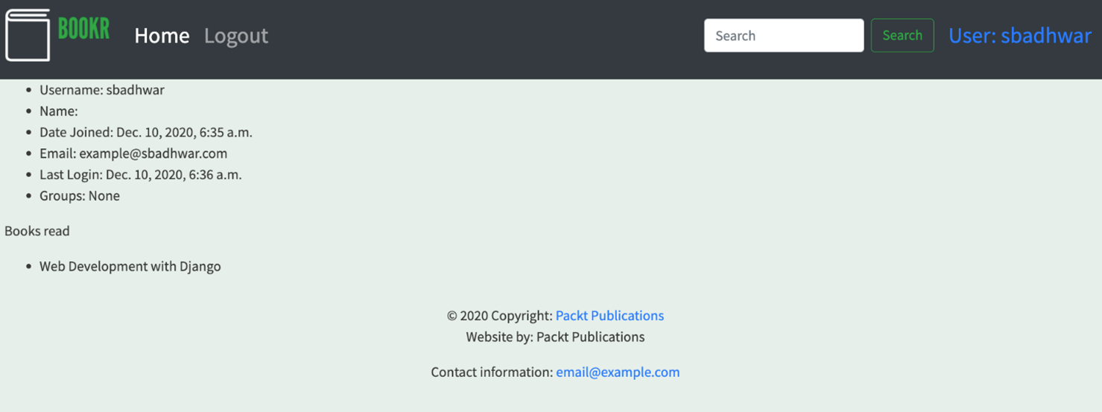

Figure 11.11: Bookr user profile page

If you are seeing a page that resembles the one shown in Figure 11.11, you have completed the activity successfully.

Chapter 12: Building a REST API

Activity 12.01: Creating an API Endpoint for a Top Contributors Page

The following steps will help you complete this activity:

1. Open bookr/reviews/models.py and add the following method to the Contributor class to count the number of contributions:

    def number_contributions(self):

        return self.bookcontributor_set.count()

1. Open bookr/reviews/serializers.py and add ContributionSerializer, which represents a single contribution made by a contributor:

from .models import BookContributor

class ContributionSerializer(serializers.ModelSerializer):

    book = BookSerializer()

    class Meta:

        model = BookContributor

        fields = ['book', 'role']

Here, we are using BookSerializer from the previous exercise to provide details regarding the specific books. In addition to the book field, we add in the role field as requested by the frontend developer.

1. Add another serializer to bookr/reviews/serializers.py to serialize Contributor objects in the database, as follows:

from .models import Contributor

class ContributorSerializer(serializers.ModelSerializer):

    bookcontributor_set = ContributionSerializer\

                          (read_only=True, many=True)

    number_contributions = serializers.ReadOnlyField()

    class Meta:

        model = Contributor

        fields = ['first_names', 'last_names',\

                  'email', 'bookcontributor_set',\

                  'number_contributions']

There are two things to note regarding this new serializer. The first is that the field bookcontributor_set is going to give us the list of contributions made by a specific contributor. Another point to note is that number_contributions uses the method we defined in the Contributor class. For this to work, we need to set this as a read-only field. This is because it does not make sense to directly update the number of contributions; instead, you would add books to the contributor.

1. Add ListAPIView like our existing AllBooks view in api_views.py:

from .models import Contributor

from .serializers import ContributorSerializer

class ContributorView(generics.ListAPIView):

    queryset = Contributor.objects.all()

    serializer_class = ContributorSerializer

1. Finally, add a URL pattern in bookr/reviews/urls.py:

path('api/contributors/'),\

path(api_views.ContributorView.as_view()),\

path(name='contributors')

You should now be able to run a server and access your API view at http://0.0.0.0:8000/api/contributors/:

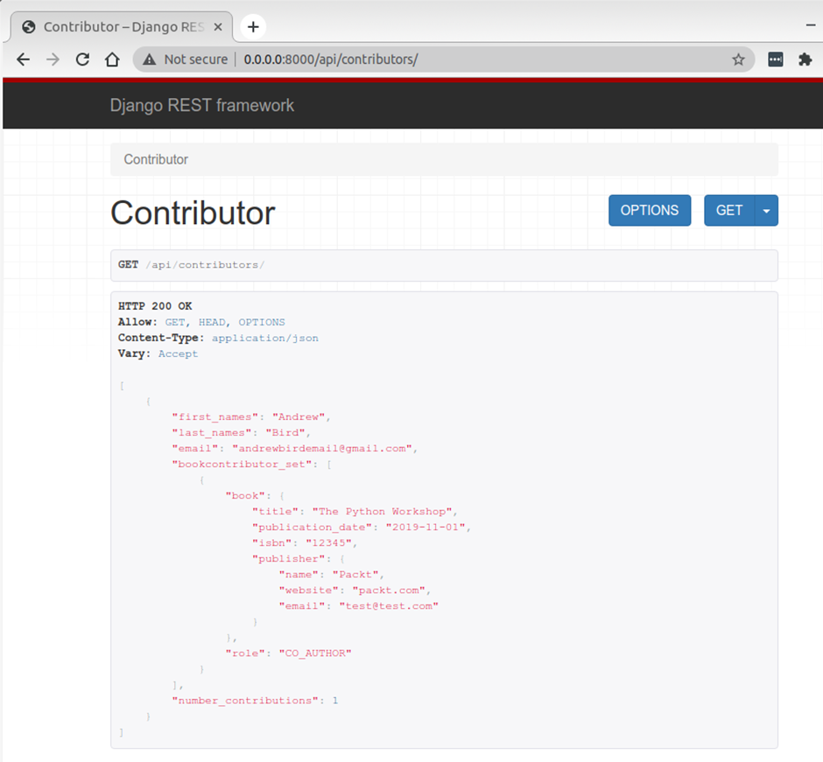

Figure 12.10: Top contributors endpoint

In this activity, you created an API endpoint to provide data to a frontend application. You used class-based views and model serializers to write clean code.

Chapter 13: Generating CSV, PDF and Other Binary Files

Activity 13.01: Exporting the Books Read by a User as an XLSLX File

1. Before you can start with the activity, you will require the XlsxWriter library to be installed. For this, run the following command:

pip install XlsxWriter

1. To export the reading history of the user, the first step will be to fetch the reading history for the currently logged-in user. For this, create a new method named get_books_read() inside the utils.py file under the bookr directory you created as a part of Exercise 13.06, Visualizing a User's Reading History on the User Profile Page, as shown in the following code snippet:

def get_books_read(username):

    """Get the list of books read by a user.

    :param: str username for whom the \

        book records should be returned

    :return: list of dict of books read \

        and date of posting the review

    """

    books = Review.objects.filter(creator__username__contains=username).all()

    return [{'title': book_read.book.title,\

            'completed_on': book_read.date_created}\

            for book_read in books]

In the preceding method, you take in the username of the currently logged-in user for whom the book reading history needs to be retrieved. Based on the username, you filter on the Review object, which is used to store the records of the books reviewed by the user.

Once the objects are filtered, the method creates a list of dictionaries, mapping the name of the book and the date on which the user finished reading the book, and returns this list.

1. With the helper method created, open the views.py file under the bookr directory and import the utility method you created in step 2 as well as the BytesIO library and the XlsxWriter package, as shown in the following code snippet:

from django.contrib.auth.decorators import login_required

from django.http import HttpResponse

from django.shortcuts import render

from plotly.offline import plot

import plotly.graph_objects as graphs

from io import BytesIO

import xlsxwriter

from .utils import get_books_read, get_books_read_by_month

1. Once you have set up the required imports, create a new view function named reading_history() as shown in the following code snippet:

@login_required

def reading_history(request):

    user = request.user.username

    books_read = get_books_read(user)

In the preceding code snippet, you first created a view function named reading_history, which will be used to serve the requests for exporting the reading history of the currently logged-in user as an XLSX file. This view function is decorated with the @login_required decorator, which enforces that only logged-in users can access this view inside the Django application.

Once the username is obtained, you then pass the username to the get_books_read() method created in step 2 to obtain the reading history of the user.

1. With the reading history obtained, you now need to build an XLSX file with this reading history. For this use case, there is no need to create a physical XLSX file on disk; you can use an in-memory file. To create this in-memory XLSX file, add the following code snippet to the reading_history function:

temp_file = BytesIO()

workbook = xlsxwriter.Workbook(temp_file)

worksheet = workbook.add_worksheet()

In the preceding code snippet, you first created an in-memory binary file using the BytesIO() class. The object returned by the BytesIO() class represents an in-memory file and supports all the operations that you would do on a regular binary file in Python.

With the file object in place, you passed this file object to the Workbook class of the xlsxwriter package to create a new workbook that will store the reading history of the user.

Once the workbook was created, you added a new worksheet to the Workbook object, which helps in organizing your data into a row-and-column format.

1. With the worksheet created, now you can parse the data you obtained as a result of the get_books_read() method call done in step 4. For this, add the following code snippet to your reading_history() function:

data = []

for book_read in books_read:

    data.append([book_read['title'], \

                 str(book_read['completed_on'])])

for row in range(len(data)):

    for col in range(len(data[row])):

        worksheet.write(row, col, data[row][col])

workbook.close()

In the preceding code snippet, you first created an empty list object to store the data to be written to the XLSX file. The object is populated by iterating over the books_read list of dictionaries and formatting it such that it represents a list of lists, where every element in the sub-list is a value for a specific column.

Once this list of lists was created, you then iterated over it to write the values for the individual columns present in a specific row.

Once all the values were written, you then went ahead and closed the workbook to make sure all the data was written correctly, and no data corruption occurred.

1. With the data now present in the in-memory binary file, you need to read that data and send it as an HTTP response to the user. For this, add the following code snippet to the reading_history() view function:

data_to_download = temp_file.getvalue()

response = HttpResponse(content_type='application/vnd.ms-excel')

response['Content-Disposition'] = 'attachment; filename=reading_history.xlsx'

response.write(data_to_download)

return response

In the preceding code snippet, you first retrieved the data stored inside the in-memory binary file by using the getvalue() method of the in-memory file object.

You then prepared an HTTP response with the ms-excel content type and indicated that this response should be treated as a downloadable file by setting the Content-Disposition header.

Once the header was set up, you then wrote the content of the in-memory file to the response object and then returned it from the view function, essentially resulting in a file download starting for the user.

1. With the view function created, the last step is to map this view function to a URL. For this, open the urls.py file under the bookr application directory and add the bold code in the following code snippet to the file:

import books.views

urlpatterns = [...,

               path('accounts/profile/reading_history'),\

              (bookr.views.reading_history),\

              (name='reading_history'),\

           ...]

1. The URL is mapped. Now start the application by running the following command:

python manage.py runserver localhost:8080

After running the command, visit http://localhost:8080/accounts/profile/reading_history.

If you are not already logged in, you will be redirected to the login page, and after a successful login, you will be prompted to accept a file download with the name reading_history.xlsx:

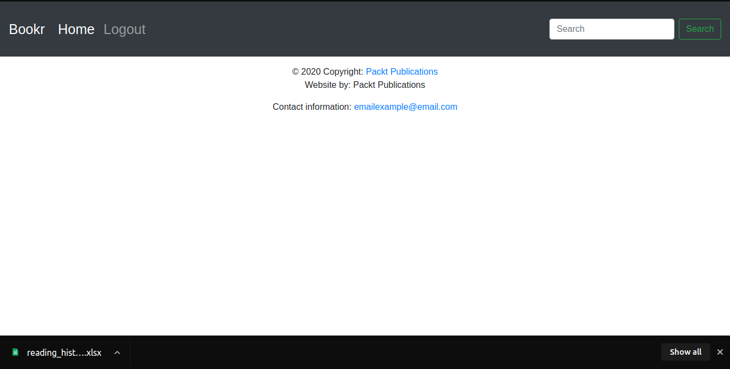

Figure 13.10: The reading_history file being downloaded

If you see a file downloading, similar to what you see in Figure 13.10, you have successfully completed the activity.

Note

In case you don't have any reading history associated with your user account, the downloaded file will be a blank Excel file.

Chapter 14: Testing

Activity 14.01: Testing Models and Views in Bookr

1. To start with, you will be writing test cases for the components of the review module that you have built so far. First, create a directory named tests/ inside the reviews application directory, which you will use to store the test cases for different components of the reviews application. This can be done by running the following command inside the reviews application directory:

mkdir tests

Once this is done, you need to make sure that Django recognizes this directory as a module and not as a regular directory. To make this happen, create an empty file with the name __init__.py under the tests directory you created just now by running the following command:

touch __init__.py

Once this is done, you can remove the tests.py file from the reviews directory since we are now moving towards the pattern of using modularized test cases.

1. Once the tests directory is created, it is time to write test cases for the components, starting with the writing of test cases for the models inside the reviews application. To do this, create a new file named test_models.py under the tests directory you created in step 1 by running the following command:

touch test_models.py

Once the file is created, add the following code to it:

test_models.py

1  from django.test import TestCase

2

3  from reviews.models import Book, Publisher, Contributor

4

5

6  class TestPublisherModel(TestCase):

7      def test_create_publisher(self):

8          publisher = Publisher.objects.create\

                       (name='Packt', website='www.packt.com',\

                        email='contact@packt.com')

9          self.assertIsInstance(publisher, Publisher)

You can find the complete code for this file at http://packt.live/3oXBX4V

In the preceding code snippet, you have written a couple of test cases for the models that you have created for the reviews application.

You started by importing Django's TestCase class and the models you are going to test in this exercise:

from django.test import TestCase

from reviews.models import Book, Publisher, Contributor

With the required classes imported, you defined the test cases. To test the Publisher model, you first created a new class, TestPublisherModel, which inherits from Django's TestCase class. Inside this class, you added the following test, which checks whether the Publisher model objects are being created successfully or not:

def test_create_publisher(self):

    publisher = Publisher.objects.create\

                (name='Packt',website='www.packt.com',\

                 email='contact@packt.com')

    self.assertIsInstance(publisher, Publisher)

This validation is performed by calling the assertIsInstance() method on the publisher object to validate its type. Following a similar pattern, you also created test cases for the Contributor and Book models. Now, you can go ahead and create test cases for the remaining models of the reviews application.

1. With the test cases for models now written, the next step is to cover test cases for our views. To do this, create a new file named test_views.py under the tests directory of the reviews application directory by running the following command from inside the tests directory:

touch test_views.py

Note

On Windows, you can create this file using Windows Explorer.

Once the file is created, you are going to write the test cases inside it. For testing, you are going to use Django's RequestFactory to test the views. Add the following code to your test_views.py file:

from django.test import TestCase, RequestFactory

from reviews.views import index

class TestIndexView(TestCase):

    def setUp(self):

        self.factory = RequestFactory()

    def test_index_view(self):

        request = self.factory.get('/index')

        request.session = {}

        response = index(request)

        self.assertEquals(response.status_code, 200)

Let us examine the code in detail. In the first two lines, you imported the required classes for writing our test cases, including TestCase and RequestFactory. Once the base classes were imported, you then imported the index method from the reviews.views module to be tested. Next up, you created TestCase by creating a new class named TestIndexView, which will encapsulate the test cases for the view functions. Inside this TestIndexView, you added the setUp() method, which will help you create a request factory instance for use in every test case:

def setUp(self):

        self.factory = RequestFactory()

With the setUp() method defined, you wrote a test case for the index view. Inside this test case, you first created a request object as if you were trying to make an HTTP GET call to the '/index' endpoint:

request = self.factory.get('/index')

Once the request object is available, you set the session object to point to an empty dictionary since you currently do not have a session available:

request.session = {}

With the session object now pointing to an empty dictionary, you could now test the index view function by passing the request object to it as follows:

response = index(request)

Once the response is generated, you validate the response by checking the status code of the response using the assertEquals method:

self.assertEquals(response.status_code, 200)

1. With the test cases now in place, run and check whether they pass successfully. To do this, run the following command:

python manage.py test

Once the command finishes, you should expect to see the following output generated:

% python manage.py test

Creating test database for alias 'default'...

System check identified no issues (0 silenced).

.........

----------------------------------------------------------------------

Ran 9 tests in 0.290s

In the preceding output, you can see that all the test cases that you implemented have passed successfully, validating that the components work in the way they are expected to.

Chapter 15: Django Third Party Libraries

Activity 15.01: Using FormHelper to Update Forms

The following steps will help you complete this activity:

1. Open the reviews app's forms.py. Create a class called InstanceForm. It should inherit from forms.ModelForm:

class InstanceForm(forms.ModelForm):

It should be the first class defined in the file as other classes will be inheriting from it.

1. At the start of the file, you should already be importing the FormHelper class from crispy_forms.helper:

from crispy_forms.helper import FormHelper

Add the __init__ method to InstanceForm. It should accept *args and **kwargs as arguments and pass them through to super().__init__():

class InstanceForm(forms.ModelForm):

    def __init__(self, *args, **kwargs):

        super().__init__(*args, **kwargs)

Then instantiate a FormHelper instance and set it to self.helper:

        self.helper = FormHelper()

This is the helper object that django-crispy-forms will query to find the form attributes. Since this form is to be submitted with POST, which is the default method of FormHelper, we don't need to set any attributes.

1. The Submit class must first be imported from crispy_forms.layout (you should already have this from Exercise 15.04, Using Django Crispy Forms with the SearchForm):

from crispy_forms.layout import Submit

Next, we need to determine the submit button's title. Inside the InstanceFrom__init__ method, check if kwargs contains an instance item. If it does, then button_title should be Save (as we are saving the existing instance). Otherwise, the button_title should be Create:

        if kwargs.get("instance"):

            button_title = "Save"

        else:

            button_title = "Create"

Finally, create a Submit button using the button_title as its second argument, then pass this to the add_input method of FormHelper:

        self.helper.add_input(Submit("", button_title))

This will create the submit button for django-crispy-forms to add to the form.

1. Change PublisherForm, ReviewForm, and BookMediaForm in this file so that instead of inheriting from models.ModelForm, they inherit from InstanceForm.

Go to the following line:

class PublisherForm(models.ModelForm):

Change it to this:

class PublisherForm(InstanceForm):

Next, go to the following line:

class ReviewForm(models.ModelForm):

Change it to this:

class ReviewForm(InstanceForm):

Finally, for BookMediaForm, go to the following line:

class BookMediaForm(models.ModelForm):

Change it to this:

class BookMediaForm(InstanceForm):

No other lines need to be changed. You can then save and close forms.py.

1. Open instance-form.html in the reviews app's templates directory. First, you must use the load template tag to load crispy_forms_tags. Add this on the second line of the file:

{% load crispy_forms_tags %}

Then scroll to the bottom of the file where the <form> tag is located. You can delete the entire form code, including the opening <form> and closing </form> tags. Then replace it with:

{% crispy form %}

This will render the form, including the <form> tags, CSRF token, and submit button. You can save and close instance-form.html.

1. Open the reviews app's views.py. In the book_media view function, locate the call to the render function. In the context dictionary, remove the is_file_upload item. The render call line code should then be like this:

return render(request,\

              "reviews/instance-form.html",\

              {"instance": book,\

               "form": form,\

               "model_type": "Book"})

We no longer need is_file_upload as the crispy template tag will automatically render the form with the correct enctype attribute if the form contains FileField or FormField fields. Save views.py.

You can now start the Django dev server and try using the Publisher, Review, and Book Media forms. You should see they look nice since they are using the proper Bootstrap classes. The submit buttons should automatically update based on the create or edit mode you are in for that form. Verify that you can update book media, which will indicate that the enctype is being set properly on the form:

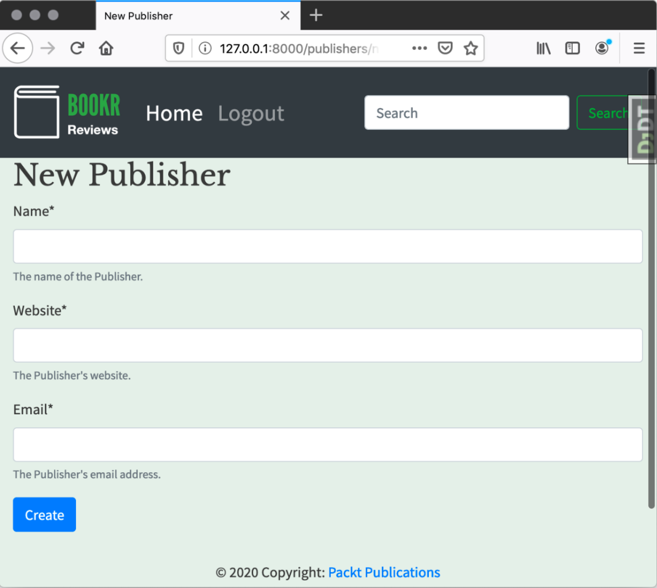

Figure 15.40: New Publisher page

The New Review form and the Book Media page should appear as follows:

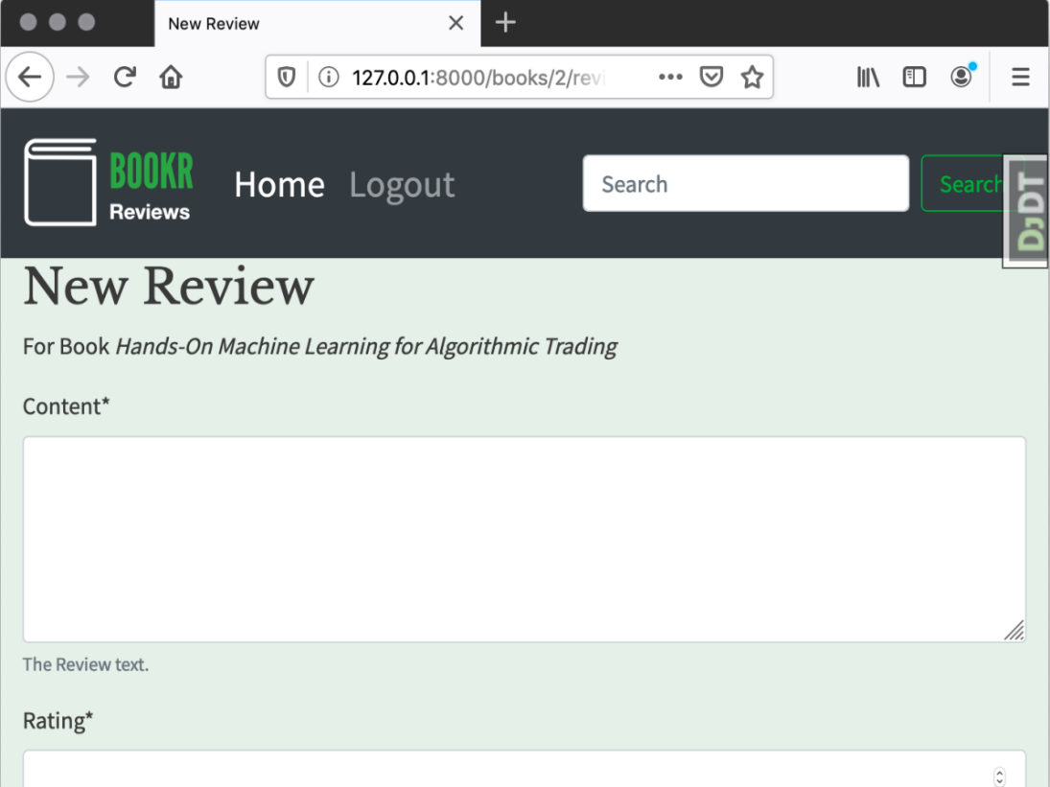

Figure 15.41: New Review form

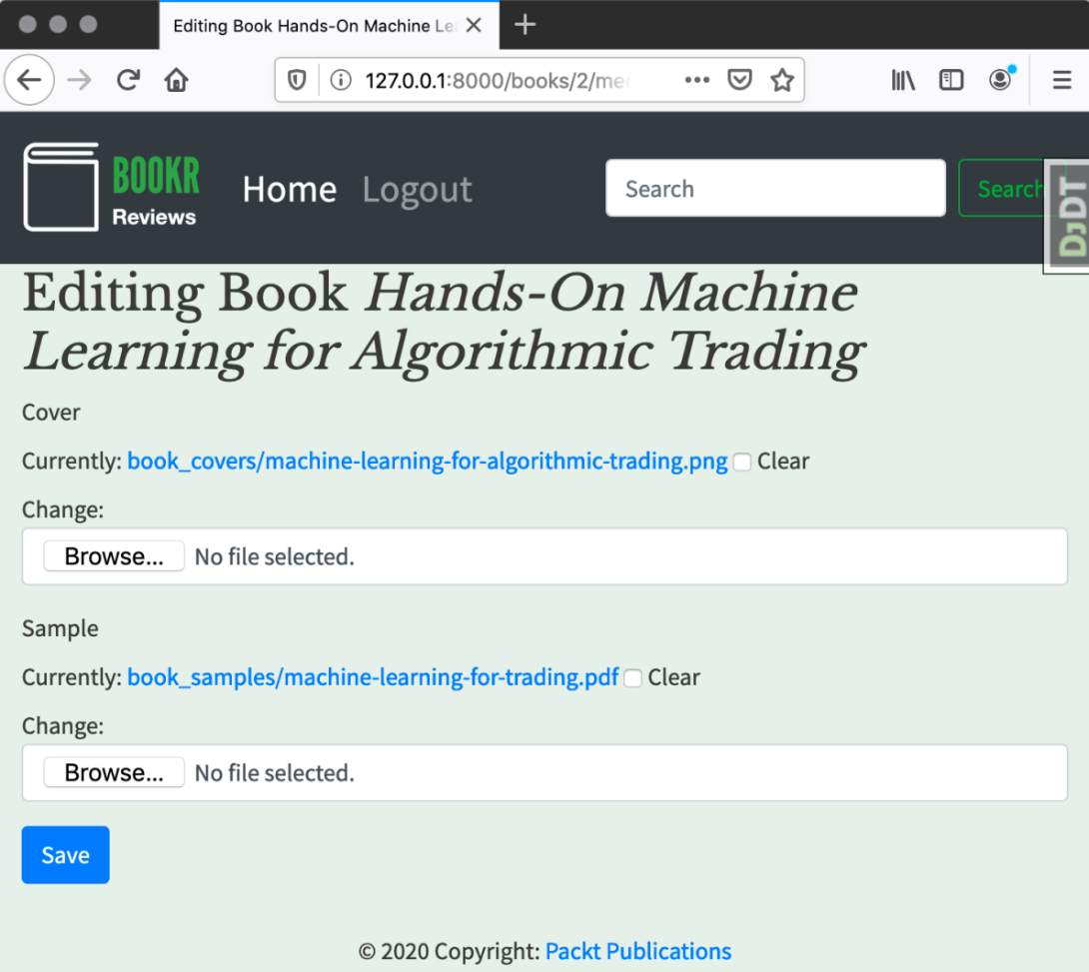

Figure 15.42: Book Media page

Chapter 16: Using a Frontend JavaScript Library with Django

Activity 16.01: Reviews Preview

The following steps will help you complete this activity:

1. Delete the react_example view from views.py. Remove the react-example URL map from urls.py, and then delete the react-example.html template file and react-example.js JavaScript file.
2. In the project's static directory, create a new file named recent-reviews.js:

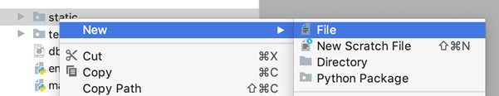

Figure 16.23: Create a JavaScript file in the main static directory

1. Define the ReviewDisplay class like this:

class ReviewDisplay extends React.Component {

  constructor(props) {

    super(props);

    this.state = { review: props.review };

  }

}

Here, the state attribute is being created with the review that will be passed in using the review attribute.

1. Implement the render method like this:

    render () {

      const review = this.state.review;

      return <div className="col mb-4">

            <div className="card">

                <div className="card-body">

                    <h5 className="card-title">{ review.book }

                        <strong>({ review.rating })</strong>

                    </h5>

                    <h6 className="card-subtitle mb-2 text-muted"  
 >{ review.creator.email }</h6>

                    <p className="card-text">  
 { review.content }</p>

                </div>

                <div className="card-footer">

                    <a href={'/books/' + review.book_id + '/' }   
 className="card-link">View Book</a>

                </div>

            </div>

        </div>;

    }

Note that it is not necessary to create a review alias variable; the data could be accessed through the state throughout the HTML. For example, { review.book } could be replaced with { this.state.review.book }. The completed class should now look like this: http://packt.live/2XSvJaN

1. Create a RecentReviews class, with a constructor method like this:

class RecentReviews extends React.Component {

    constructor(props) {

      super(props);

      this.state = {

          reviews: [],

          currentUrl: props.url,

          nextUrl: null,

          previousUrl: null,

          loading: false

      };

    }

}

This reads the currentUrl from the one provided in props and other values are set as defaults.

1. Create a fetchReviews method that returns immediately if a load is in process:

fetchReviews() {

  if (this.state.loading)

      return;

this.setState( {loading: true} );

}

1. After setting the state in the previous step, add the call to the fetch function:

fetch(this.state.currentUrl, {

  method: 'GET',

  headers: {

      Accept: 'application/json'

  }

}).then((response) => {

  return response.json()

}).then((data) => {

this.setState({

      loading: false,

      reviews: data.results,

nextUrl: data.next,

previousUrl: data.previous

  })

})

This will fetch the currentUrl, and then update nextUrl and previousUrl to the values of next and previous that the Django server generates. We also set our reviews to the data.results we retrieved and set loading back to false since the load is complete.

1. The componentDidMount method simply calls the fetchReviews method:

componentDidMount() {

  this.fetchReviews()

}

This method is called by React when the component first renders.

1. The loadNext method should return if there is no nextUrl. Otherwise, set currentUrl to nextUrl. Then, call fetchReviews:

loadNext() {

  if (this.state.nextUrl == null)

      return;

  this.state.currentUrl = this.state.nextUrl;

  this.fetchReviews();

}

1. loadPrevious is like loadNext, with previousUrl used in place of nextUrl:

loadPrevious() {

  if (this.state.previousUrl == null)

      return;

  this.state.currentUrl = this.state.previousUrl;

  this.fetchReviews();

}

1. The render method is quite long. We will look at it in chunks. First, it should return some loading text if state.loading is true:

if (this.state.loading) {

  return <h5>Loading...</h5>;

}

1. Still inside the render method, we'll now create the previous and next buttons and assign them to the previousButton and nextButton variables respectively. Their onClick action is set to trigger the loadPrevious or loadNext method. We can disable them by checking if previousUrl or nextUrl are null. Here is the code:

        const previousButton = <button

            className="btn btn-secondary"

            onClick={ () => { this.loadPrevious() } }

            disabled={ this.state.previousUrl == null }>

                Previous

        </button>;

        const nextButton = <button

            className="btn btn-secondary float-right"

            onClick={ () => { this.loadNext() } }

            disabled={ this.state.nextUrl == null }>

                Next

        </button>;

Note that nextButton has the additional class float-right, which displays it on the right of the page.

1. Next, we define the code that displays a list of ReviewDisplay elements:

if (this.state.reviews.length === 0) {

reviewItems = <h5>No reviews to display.</h5>

} else {

reviewItems = this.state.reviews.map((review) => {

        return <ReviewDisplay key={review.pk} review={review}/>

    })

}

If the length of the reviews array is 0, then the content to display is set to <h5>No reviews to display.</h5>. Otherwise, we iterate over the reviews array using its map method. This will build an array of ReviewDisplay elements. We give each of these a unique key of review.pk, and also pass in the review itself as a property.

1. Finally, all the content we built is bundled together inside some <div> instances and returned, as per the example given:

return <div>

<div className="row row-cols-1 row-cols-sm-2 row-cols-md-3">

      { reviewItems }

</div>

<div>

      {previousButton}

      {nextButton}

</div>

</div>;

The finished RecentReviews class is at http://packt.live/2M1fllB.

You can save and close recent-reviews.js.

1. Open the project's base.html (not the reviews-specific one). Between the {% block content %} and {% endblock %} template tags, after the closing {% endif %} containing the previously viewed book history, add the Recent Reviews heading:

<h4>Recent Reviews</h4>

1. Underneath the <h4> added in the previous step, create a <div> element, with a unique id attribute:

<div id="recent_reviews"></div>

In this example, we are using an id of recent_reviews, but yours could be different. Just make sure you use the same ID when referring to the <div> in step 18.

1. Under the <div> that was just added, but still before the {% endblock %}, add your <script> elements:

<script crossorigin src="https://unpkg.com/react@16/umd/react.development.js"></script>

<script crossorigin src="https://unpkg.com/react-dom@16/umd/react-dom.development.js"></script>

<script crossorigin src="https://unpkg.com/babel-standalone@6/babel.min.js"></script>

<script src="{% static 'recent-reviews.js' %}" type="text/babel"></script>

1. Finally, add another <script> element to render the React component:

<script type="text/babel">

ReactDOM.render(<RecentReviews url="{% url 'api:review-list' %}?  
 limit=6" />,

document.getElementById('recent_reviews')

        );

</script>

The url that is passed into the component's prop is generated by Django's url template tag. We manually append the ?limit=6 argument to limit the number of reviews that are returned. In the document.getElementById call, make sure you use the same ID string that you gave to your <div> in step 16.

Start the Django dev server if it is not already running, then go to http://127.0.0.1:8000/ (the Bookr main page). You should see the first six reviews and be able to page through them by clicking the Previous and Next buttons:

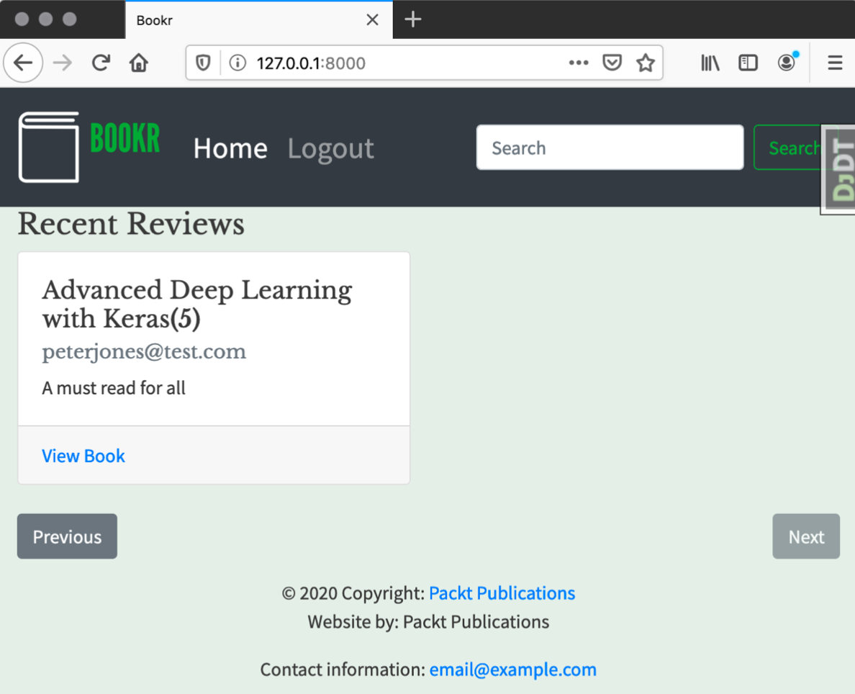

Figure 16.24: Last page of reviews

Chapter 17: Deployment of a Django Application (Part 1 – Server Setup)

Activity 17.01: Installing glances – A System-Monitoring Utility

1. Make sure your virtual machine is running (start it in VirtualBox if necessary), and then connect to it using the SSH command or PuTTY, as you have done earlier in this chapter.
2. To update the list of available packages, use the apt update command. It must be run with sudo, and you may have to enter your password. Your output will be similar to the following:

ben@bookr:~$ sudo apt update

[sudo] password for ben:

Hit:1 http://nz.archive.ubuntu.com/ubuntu bionic InRelease

Get:2 http://nz.archive.ubuntu.com/ubuntu bionic-updates InRelease [88.7 kB]

Get:3 http://nz.archive.ubuntu.com/ubuntu bionic-backports InRelease [74.6 kB]

Get:4 http://nz.archive.ubuntu.com/ubuntu bionic-security InRelease [88.7 kB]

Get:5 http://nz.archive.ubuntu.com/ubuntu bionic-updates/main amd64 Packages [1038 kB]

Get:6 http://nz.archive.ubuntu.com/ubuntu bionic-updates/universe amd64 Packages [1101 kB]

Fetched 2391 kB in 1s (1699 kB/s)

Reading package lists... Done

Building dependency tree

Reading state information... Done

All packages are up to date.

ben@bookr:~$

Remember that this is just updating the list of available packages. To upgrade packages to the latest version(s), you would use the apt upgrade command.

1. Install glances with the sudo apt install glances command. Since you've just run sudo recently, you shouldn't have to enter your password again. It will show you which packages it needs to install (quite a few), and then you'll have to just press Enter to continue. You'll see an output as in Figure 17.63:

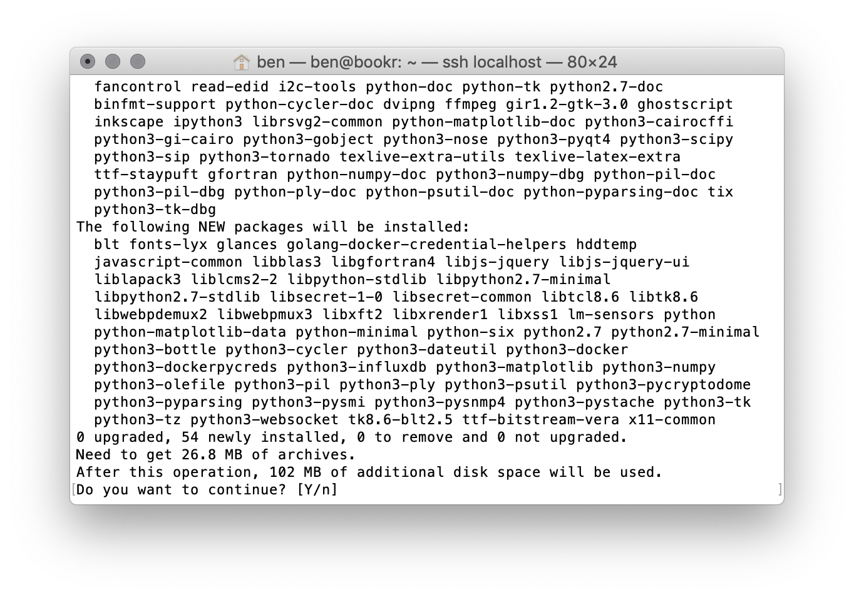

Figure 17.63: Prompt to install glances

After it has been installed, you will return to the command prompt.

1. Run the glances command to start glances. It will look as follows:

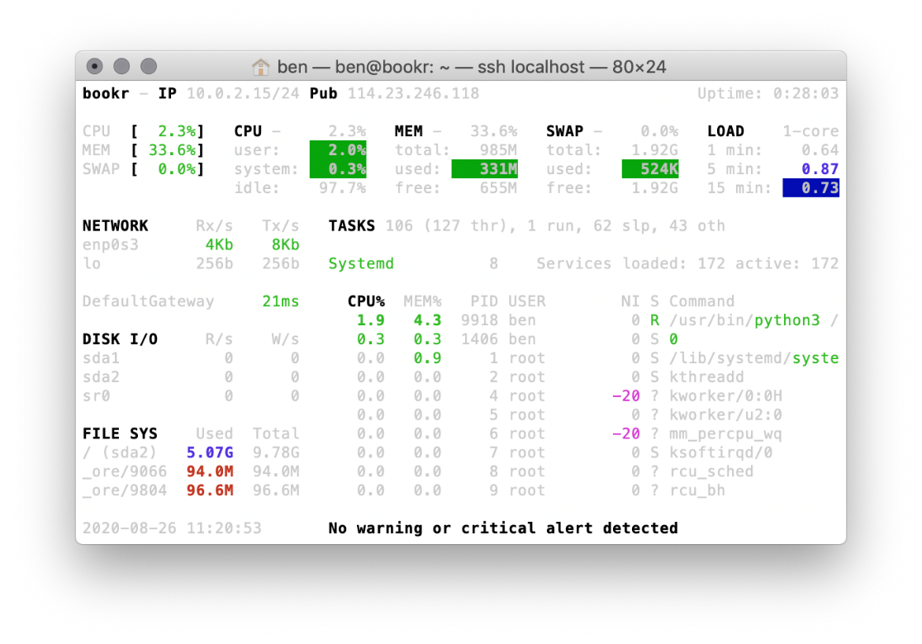

Figure 17.64: glances default appearance

After you've had a look at its interface, quit glances by pressing Ctrl + C or Esc.

1. Run man glances to view the glances manual page (or man page for short). When it starts, it looks as in Figure 17.65:

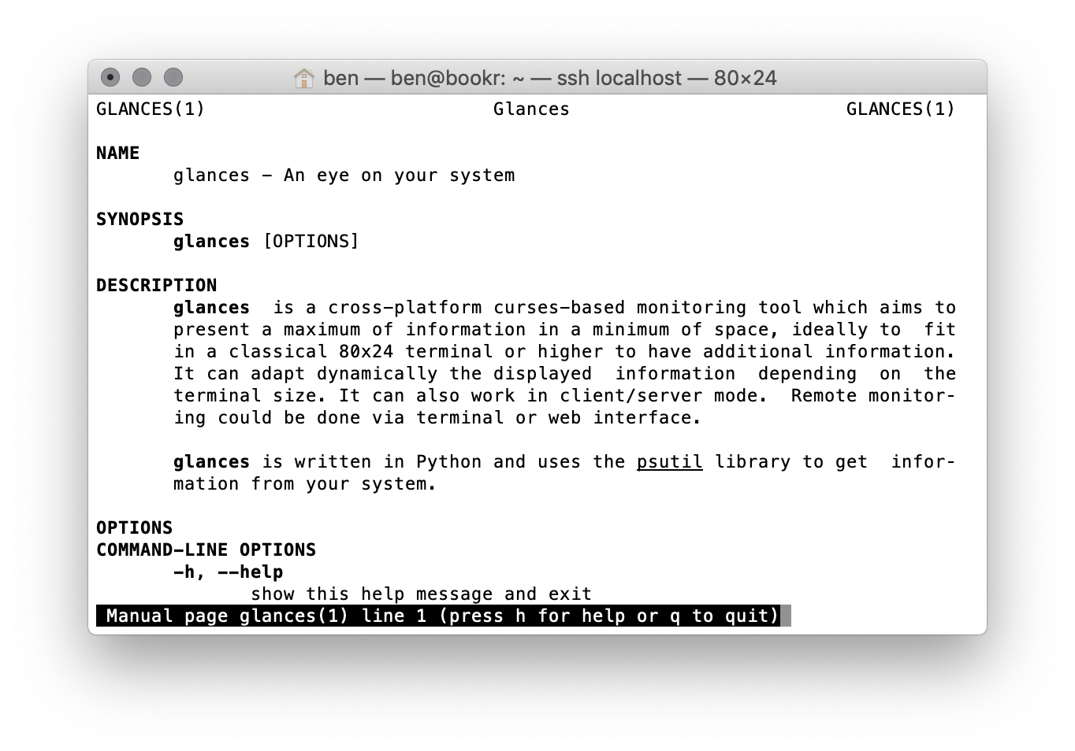

Figure 17.65: glances manual page

You can navigate up and down through the file by using the cursor keys, and type q to quit. You can also search inside the file by typing /, then the search term, then press Enter to perform the search. Matches will be highlighted, and you can type n to move forward through the results or Shift + N to move backward:

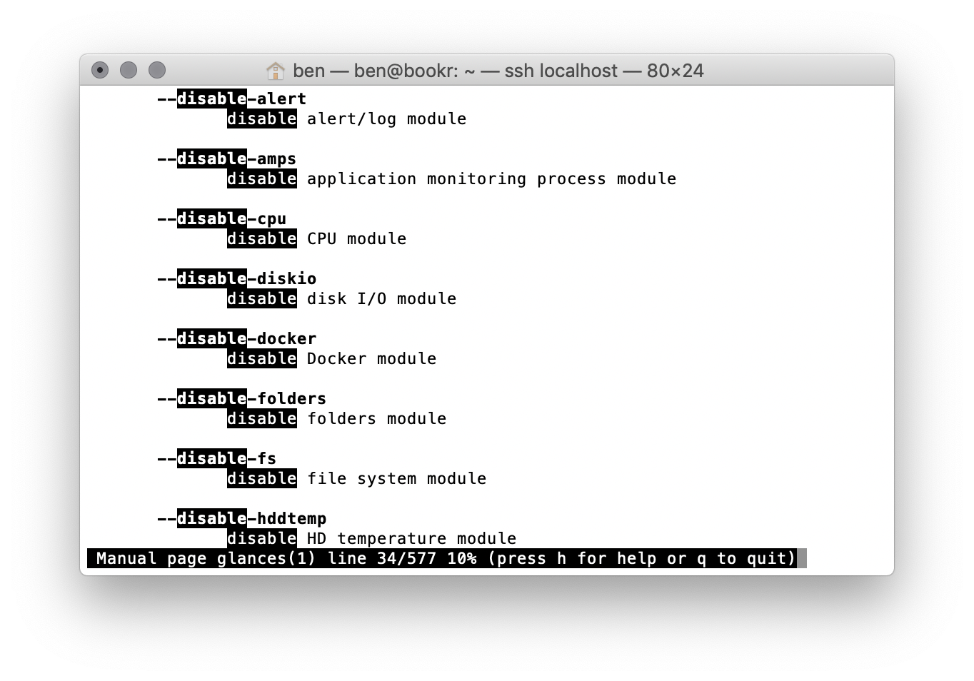

Figure 17.66: Searching for "disable"

This can make it easy to find what you're looking for, by searching for disable and theme. Figure 17.67 shows the section of the manual that explains how to disable the memory swap module, using --disable-memswap:

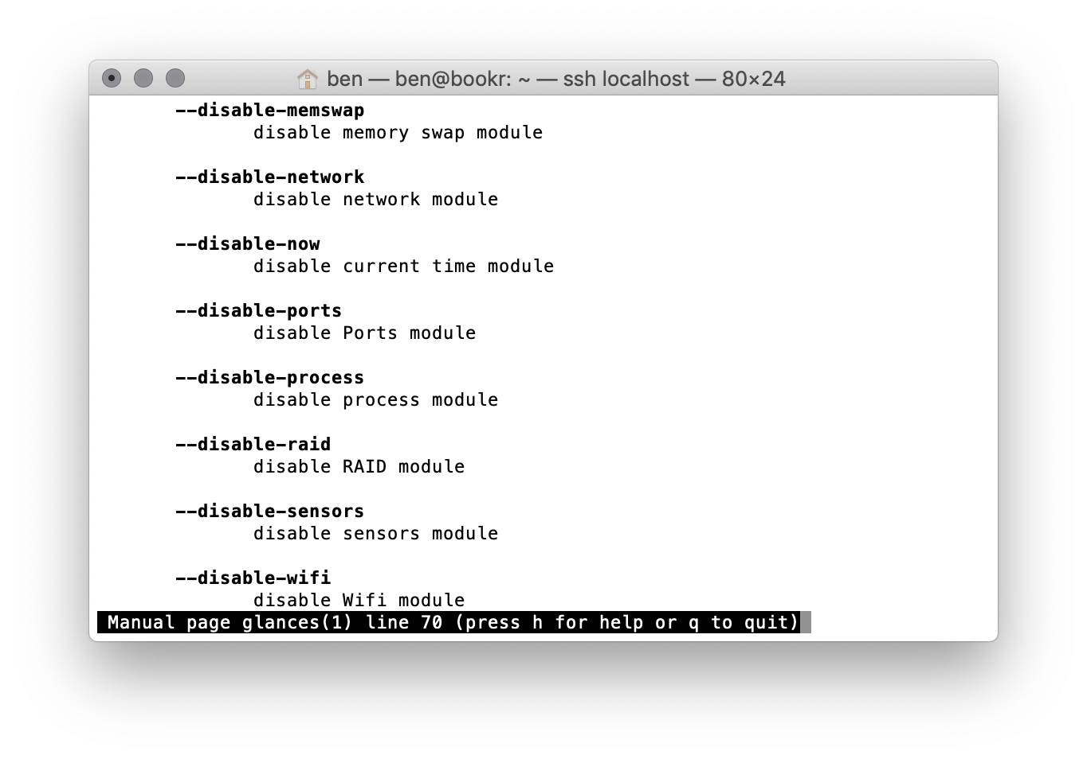

Figure 17.67: Disabling the memory swap module with the –disable-memswap argument

Figure 17.68 shows the section for setting the white theme, using the --theme-white argument: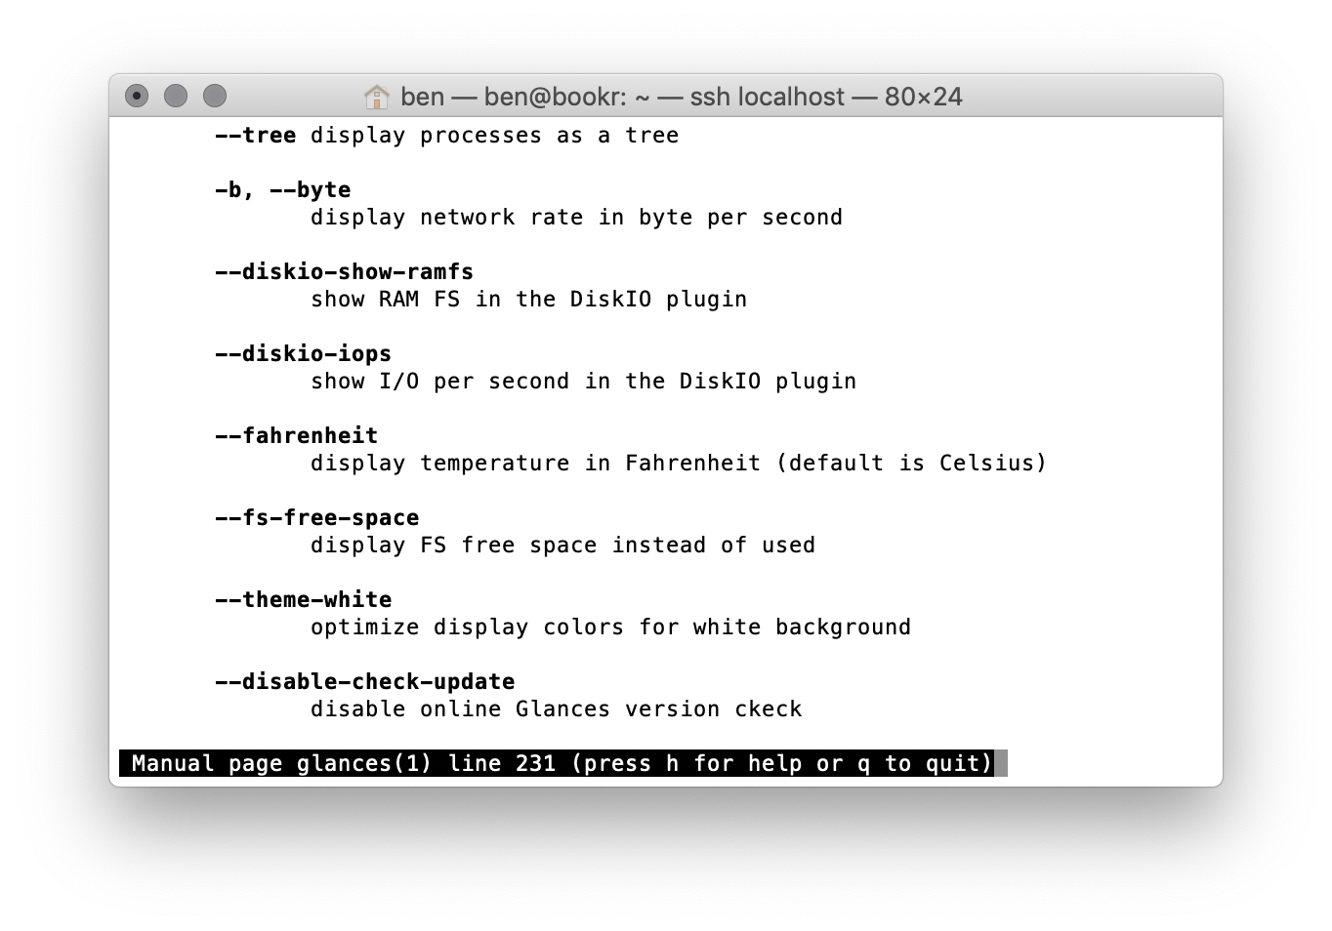

Figure 17.68: Setting a white theme using the --theme-white argument

Now, quit the man program by typing q.

1. Re-run glances with the --disable-memswap argument, and if you have a white terminal background, then use the --theme-white argument:

glances --disable-memswap --theme-white

You should see glances display now without the swap memory information, and it should be more readable:

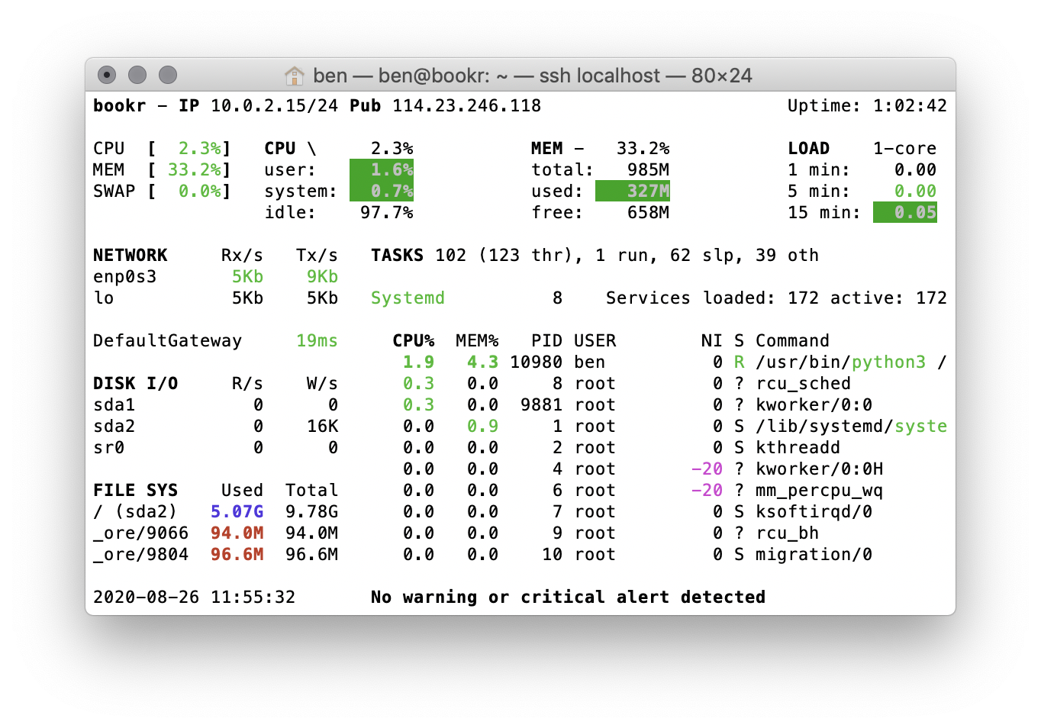

Figure 17.69: glances with a white theme and without the memory swap module shown

Once again, you can quit glances and disconnect and shut down your virtual machine, if you've finished using it.

Chapter 18: Deployment of a Django Application (Part 2 – Configuration and Code Deployment)

Activity 18.01: Management Commands

1. Start VirtualBox and boot up your virtual machine. Open an SSH connection to it, using the address you have been using throughout the chapter.
2. Switch to the bookr user with:

sudo -H u bookr /bin/bash

You might have to enter your user password for sudo:

sudo -H -u bookr /bin/bash

ben@bookr:~$ sudo -H -u bookr /bin/bash

[sudo] password for ben:

bookr@bookr:/home/ben$

1. Change to the bookr home directory by running cd with no arguments:

bookr@bookr:/home/ben$ cd

bookr@bookr:~$

1. Activate the virtual environment in the usual way, by using source to load the activate script:

bookr@bookr:~$ source bookr-venv/bin/activate

(bookr-venv) bookr@bookr:~$

Notice that your command prompt changes to include the virtual environment name (bookr-venv) after it has been activated.

1. The settings need to be exported into the current environment using the export command we saw in Exercise 18.04, Python Virtual Environment and Django Setup, step 9:

export $(cat production.conf | xargs)

First, you should cd into the bookr directory before running it, otherwise, the path to production.conf will not be correct:

(bookr-venv) bookr@bookr:~$ cd bookr

(bookr-venv) bookr@bookr:~/bookr$ export $(cat production.conf | xargs)

(bookr-venv) bookr@bookr:~/bookr$

1. Now that the virtual environment is activated and the configuration is loaded, we can run Django management commands in the usual manner. The loadcsv command should be run with the path to the CSV file containing the test data:

python3 manage.py loadcsv --csv reviews/management/commands/WebDevWithDjangoData.csv

Its output is as follows:

(bookr-venv) bookr@bookr:~/bookr$ python3 manage.py loadcsv --csv reviews/management/commands/WebDevWithDjangoData.csv

Created Publisher "Packt Publishing"

…

Created Contributor "Rowel Atienza"

…

Created BookContributor "RowelAtienza@example.com" -> "Advanced Deep Learn…

Created User "peterjones@test.com"

Created Review: "Advanced Deep Learning with Keras" -> "peterjones@test.com"

…

Import complete

(bookr-venv) bookr@bookr:~/bookr$

Some output has been truncated for brevity.

1. Similarly, the createsuperuser management command can now be run. This is the same as how it was run in Chapter 4, Introduction to Django Admin:

python3 manage.py createsuperuser

You should then follow the prompts on the screen:

(bookr-venv) bookr@bookr:~/bookr$ python3 manage.py createsuperuser

Username (leave blank to use 'bookr'): ben

Email address: ben@example.com

Password:

Password (again):

Superuser created successfully.

(bookr-venv) bookr@bookr:~/bookr$

Now load up the Bookr hosted on your server in a web browser. You should see it populated with test data:

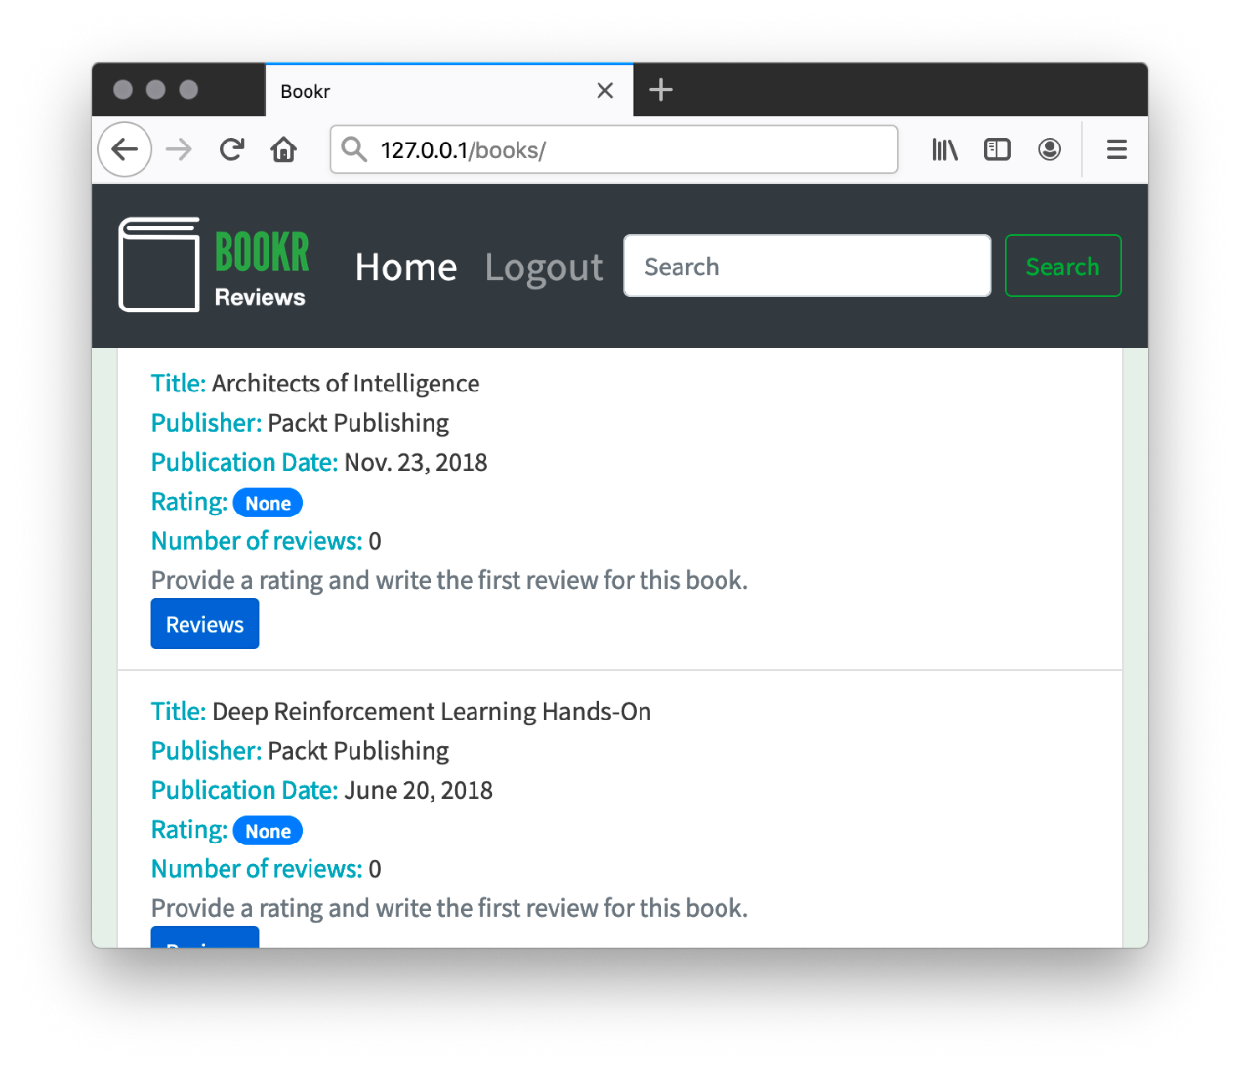

Figure 18.14: Bookr populated with test data

Figure 18.14 shows Bookr running on a virtual machine with some test data. Note that, depending on the CSV import, your data may be ordered differently.

You should also be able to log in to the Django admin section with the credentials you created in step 7.

In this activity, you saw the steps needed to log in to your server and execute Django management commands. Other commands are executed in the same way, and you can refer to these steps if you need to run other commands, such as database migrations or running collectstatic again.

Activity 18.02: Code Updates

1. In PyCharm, open the main.css file. Find the body section. Change the background-color rule. Currently, this is as follows:

background-color: #e6efe8;

Change this to the following:

background-color: #f0f0f0;

Save and close the file.

1. Open reviews/templates/reviews/index.html. Add an <h2> element just after the opening {% block content %} template tag. Its content should be like this:

<h2>Welcome to Bookr!</h2>

Save and close the file.

1. Make sure your virtual machine has been booted up, then connect to it using FileZilla. Upload main.css and index.html. You can just put them in your home directory without any directory structure as you will be moving them in the next step:

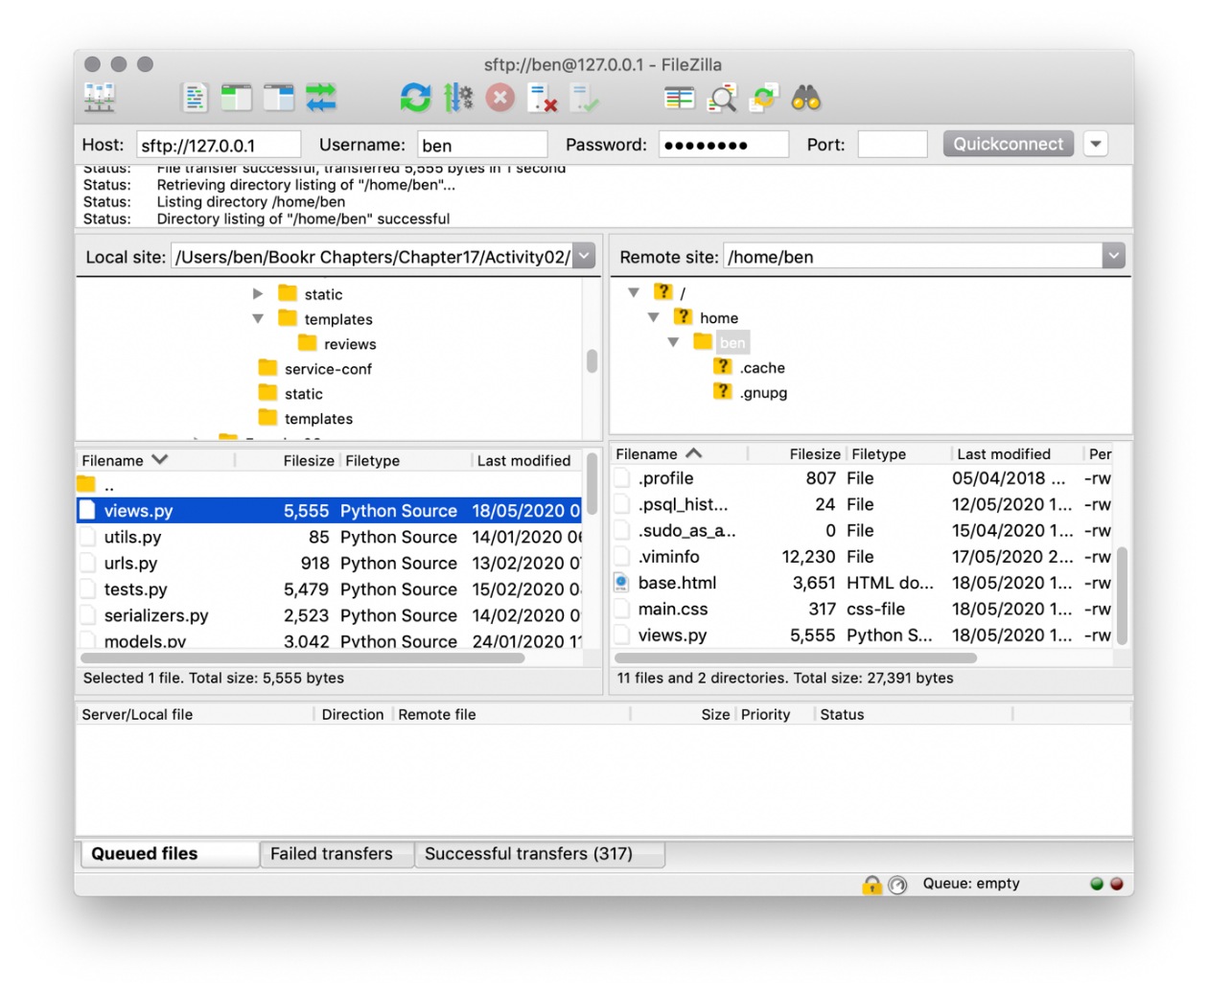

Figure 18.15: Uploaded Files in the remote home directory

1. SSH into your virtual machine and use mv (with sudo) to move the files to the correct places:

sudo mv index.html /home/bookr/bookr/templates/

sudo mv main.css /home/bookr/bookr/static/

Then update their ownership – this can be done with one command:

sudo chown bookr:bookr /home/bookr/bookr/templates/index.html /home/bookr/bookr/static/main.css

These steps and their output are shown here:

ben@bookr:~$ sudo mv index.html /home/bookr/bookr/templates/

[sudo] password for ben:

ben@bookr:~$ sudo mv main.css /home/bookr/bookr/static/

ben@bookr:~$ sudo chown bookr:bookr /home/bookr/bookr/templates/index.html /home/bookr/bookr/static/main.css

ben@bookr:~$

1. Switch to the bookr user with sudo:

sudo -H -u bookr /bin/bash

Change into the bookr home directory with cd (with no arguments):

cd

Activate the virtual environment using source:

source bookr-venv/bin/activate

Change into the bookr project directory with cd:

cd bookr

Export production settings:

export $(cat production.conf | xargs)

Then you can run the collectstatic command:

python3 manage.py collectstatic

All these commands should produce output like this:

ben@bookr:~$ sudo -H -u bookr /bin/bash

bookr@bookr:/home/ben$ cd

bookr@bookr:~$ source bookr-venv/bin/activate

(bookr-venv) bookr@bookr:~$ cd bookr

(bookr-venv) bookr@bookr:~/bookr$ export $(cat production.conf | xargs)

(bookr-venv) bookr@bookr:~/bookr$ python3 manage.py collectstatic

You have requested to collect static files at the destination

location as specified in your settings:

    /var/www/bookr/static

This will overwrite existing files!

Are you sure you want to do this?

Type 'yes' to continue, or 'no' to cancel: yes

1 static file copied to '/var/www/bookr/static', 178 unmodified.

(bookr-venv) bookr@bookr:~/bookr$

One static file (main.css) will be copied.

1. Switch back to your normal user with the exit command. Then restart gunicorn-bookr using systemctl:

sudo systemctl restart gunicorn-bookr

You'll see no output if the command was successful:

(bookr-venv) bookr@bookr:~/bookr$ exit

exit

ben@bookr:~$ sudo systemctl restart gunicorn-bookr

ben@bookr:~$

Load Bookr hosted on your virtual machine using your web browser. You should see the updated color and welcome messages as follows: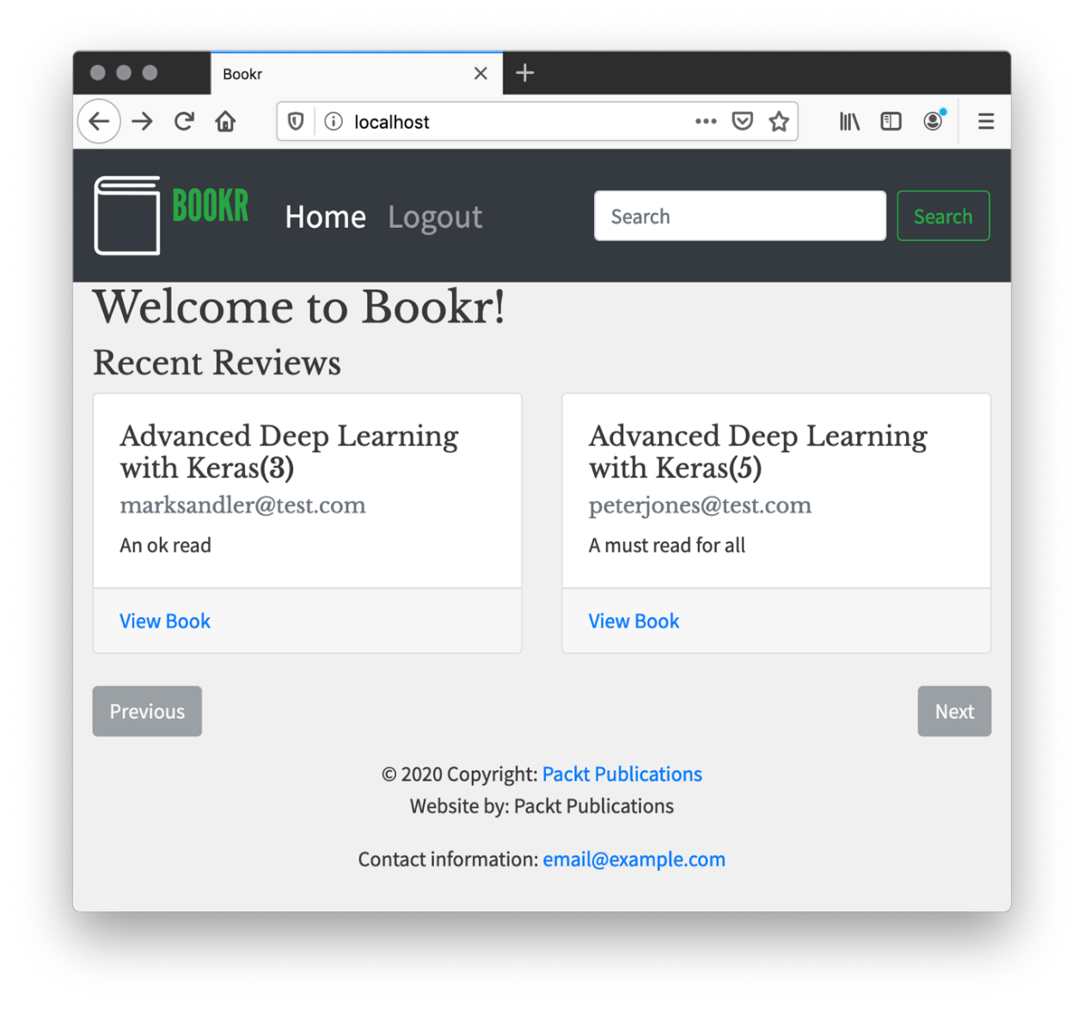

Figure 18.16: Welcome message